**NETWORKING & SYSTEM ADMINISTRATION LAB**

|  |
| --- |
| **Name: jobin t j**  **Roll No:7**  **Batch:MCA-B**  **Date:06-04-2022** |

**Experiment No: 1**

**Aim**

Introduction to Computer hardware: Physical identification of major components of a computer system such as mother board, RAM modules, daughter cards, bus slots, SMPS, internal storage devices, interfacing ports

**Procedure**

1]MOTHERBOARD

The motherboard is the main circuit board of your computer and is also known as the mainboard or logic board. If you ever open your computer, the biggest piece of silicon you see is the motherboard. Attached to the motherboard, you'll find the CPU, ROM, memory RAM expansion slots, PCI slots, and USB ports.

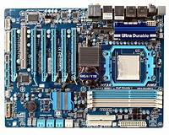

2]MONITOR

A monitor is an electronic output device that is also known as a **video display terminal** (VDT) or a **video display unit** (VDU). It is used to display images, text, video, and graphics information generated by a connected computer via a computer's video card. Although it is almost like a TV, its resolution is much higher than a TV. The first computer monitor was introduced on **1 March 1973**, which was part of the Xerox Alto computer system.

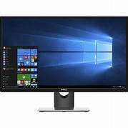

3]PRINTER

A printer is a hardware output device that is used to generate hard copy and print any document. A document can be of any type such as a text file, image, or the combination of both. It accepts input command by users on a computer or on other devices to print the documents. For example, if you have to submit a project report at your college, you need to create a soft copy of your report and print it with the help of the printer.

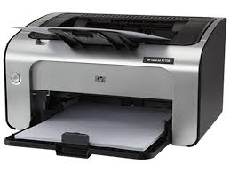

4]PROCESSOR

A processor is an integrated electronic circuit that performs the calculations that run a computer. A processor performs arithmetical, logical, input/output (I/O) and other basic instructions that are passed from an operating system (OS). Most other processes are dependent on the operations of a processor.

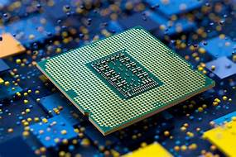

5]RAM

RAM (Random Access Memory) is the hardware in a computing device where the operating system (OS) application programs and data in current use are kept so they can be quickly reached by the device's processor. RAM is the main memory in a computer. It is much faster to read from and write to than other kinds of storage, such as a hard disk drive (HDD), solid-state drive (SSD)or optical drive.

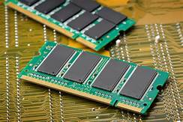

6]ROM

Read Only Memory (ROM) is computer memory that can permanently store data and applications within it. There are various types of ROM with names like EPROM (Eraseable ROM) or EEPROM (Electrically Eraseable ROM).

Unlike RAM, when a computer is powered down, the contents of the ROM are not lost. EPROM or EEPROM can have their contents rewritten by a special operation. This is called 'Flashing the EPROM' a term that came about because ultra violet light is used to clear the contents of the EPROM.

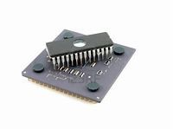

7]SYSTEM UNIT

A typical desktop computer is composed of a computer system unit, a keyboard, a mouse, and a monitor. The computer system unit is the outer shell of all other main internal components of the computer. It is also called a computer case, computer case, or computer tower. The housing is usually made of steel or aluminum, but plastics can also be used.

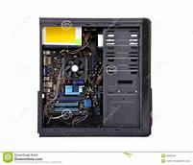

8]CPU

Stands for "Central Processing Unit." The CPU is the primary component of a computer that processes instructions. It runs the operating system and applications, constantly receiving input from the user or active software programs. It processes the data and produces output, which may be stored by an application or displayed on the screen.

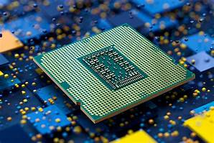

9]MOUSE

A mouse is a hand-held device used for directly interacting with a graphical gui interface y controlling the movement of a cursor or pointer on a computer Display screen. The mouse detects the two-dimensional motion of the operator and translates it into the movement of the cursor on the screen. The most common operations are point-and-click and drag-and-drop

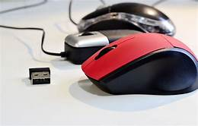

10]KEYBOARD

The keyboard is the piece of [computer hardware](https://www.lifewire.com/computer-hardware-2625895) used to input text, characters, and other commands into a computer or similar device.

Even though the keyboard is an external [peripheral device](https://www.lifewire.com/peripheral-device-2625951) in a desktop system (it sits outside the main [computer housing](https://www.lifewire.com/what-is-a-computer-case-2618149)), or is "virtual" in a tablet PC, it is an essential part of the complete computer

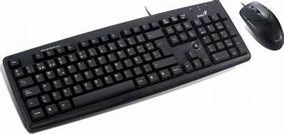system.

11]Flash memory card

The keyboard is the piece of [computer hardware](https://www.lifewire.com/computer-hardware-2625895) used to input text, characters, and other commands into a computer or similar device.

Even though the keyboard is an external [peripheral device](https://www.lifewire.com/peripheral-device-2625951) in a desktop system (it sits outside the main [computer housing](https://www.lifewire.com/what-is-a-computer-case-2618149)), or is "virtual" in a tablet PC, it is an essential part of the complete computer system.

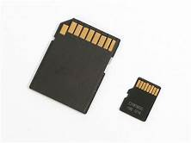

12]STORAGE

Primary Storage Devices: It is also known as internal memory and main memory. This is a section of the CPU that holds program instructions, input data, and intermediate results. It is generally smaller in size.

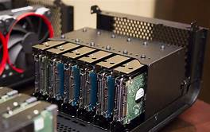

13]INPUT DEVICES AND OUTPUT DEVICES

The functioning of a computer system is based on the combined usage of both input and output devices. Using an input device we can give instructions to the computer to perform an action and the device reverts to our action through an output device.

14]GPU[GRAPHICS PROCESS UNIT]

A **graphics processing unit** (**GPU**) is a specialized electronic circuit designed to rapidly manipulate and alter [memory](https://en.wikipedia.org/wiki/Memory_(computing)) to accelerate the creation of images in a frame buffer intended for output to a display device. GPUs are used in embedded systems, mobile phones personal computers, workstations and game consoles.

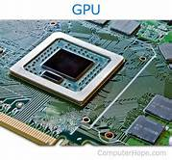

15]CONTROL UNIT

It is the responsibility of the Control Unit to tell the computer’s memory, arithmetic/logic unit and input and output devices how to respond to the instructions that have been sent to the processor.

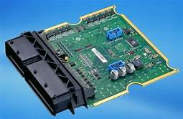

**NETWORKING & SYSTEM ADMINISTRATION LAB**

|  |
| --- |
| **Name: jobin t j**  **Roll No:7**  **Batch:MCA-B**  **Date:06-04-2022** |

**Experiment No: 2**

**Aim**

Install latest version of Ubuntu on a virtual box

**Procedure**

1. Download and Virtualbox Windows 10 Installation

2. Ubuntu ISO download

3. Install Virtualbox

4. Create an Ubuntu VM

5. Install Ubuntu on Virtualbox Windows 10

6. Install Virtualbox Guest Additions

## Download and Virtualbox Windows 10 Installation

## 1.Install Ubuntu on VirtualBox

## 2. How To Install Ubuntu On Virtual Box?

### 2.1. Open VirtualBox

### 2.2. Click on “New” to create a virtual machine

### 2.3. Enter Name for your Virtual Machine

### 2.4. Select “Linux” Operating System from “Type”

### 2.5. Click “Next”

### 2.6. Enter amount of memory (RAM) =1024 MB and click “Next”

### 2.7. Click “Create” to create hard drive

### 2.8. Click “Next”

### 2.9. Click “Next”

### 2.10. Enter Size of Virtual Hard Drive= 20 GB and Click “Create”

### 2.11. Select Virtual Machine

### 2.12. Click on “Start” to start the virtual machine

### 2.13. Select disk file source

### 2.14. After selecting the OS file to be installed click “Open”

### 2.15. Click “Start”

### 2.16. Click “Ok”

### 2.17. Click “Install Ubuntu”

### 2.18. Click “Continue”

### 2.19. Click “Install Now”

### 2.20. Click “Continue”

### 2.21. Select location and click “Continue”

### 2.22. Select keyboard layout & click “Continue”

### 2.23. Fill all the details and Click “Continue”

### 2.24. Now the installation process will start and installation window will appear

### 2.25. Click “Restart Now”

### 2.26. When the system will get restarted the following message will appear. Press “Enter”

### 2.27. Close the pop-up messages by clicking on the Close (×) button

## 3. Steps To Maximize The Size Of Ubuntu Desktop

### 3.1. Go to “Devices”

### 3.2. Click “Insert Guest Additions CD Image…”

### 3.3. Click “Run”

### 3.4. Click “Authenticate”

### 3.5. Press “Enter”

### 3.6. Now “Restart” your system for the changes to be applied.

### 3.7. After the system gets restarted. Go to “View”

### 3.8. Click “Switch to Fullscreen”

### 3.9. Click “Switch”

**Output**

**Step 1:** [Download VirtualBox](https://www.virtualbox.org/wiki/Downloads) for Windows and install it on your computer

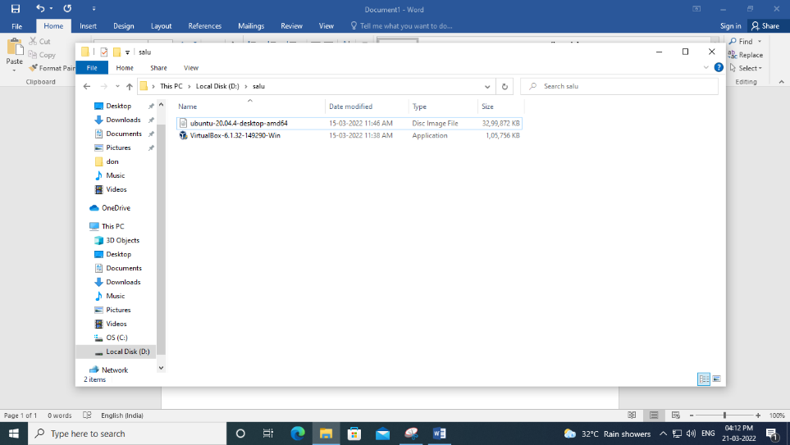

INSTALL UBUNTU VIRTUAL BOX

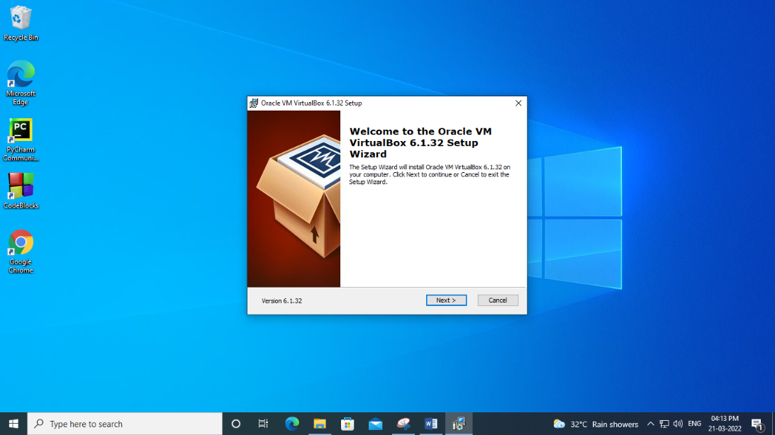

CLICK NEXT

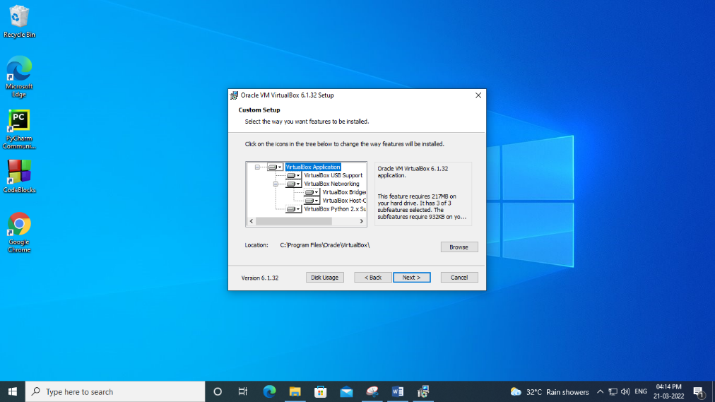

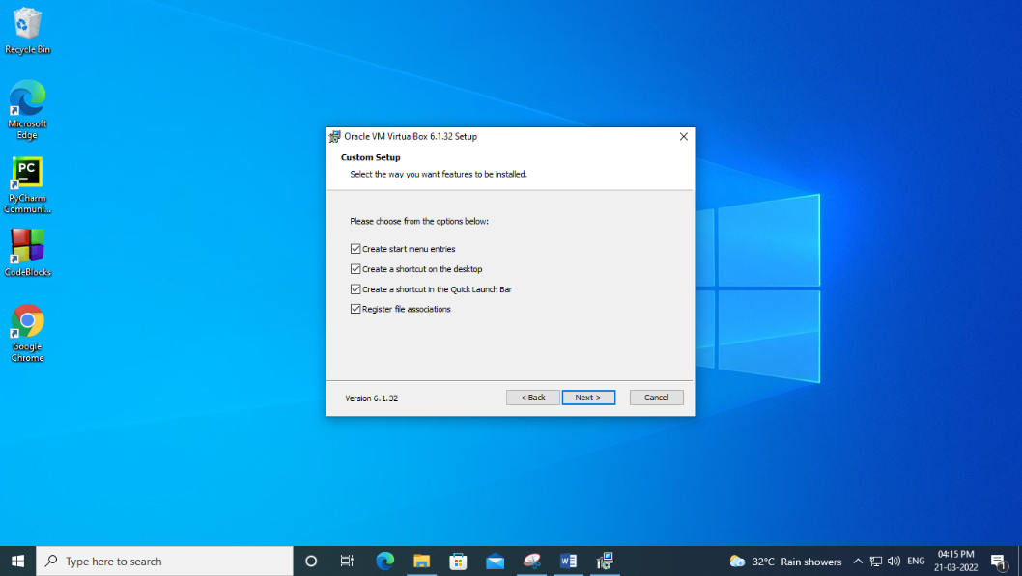

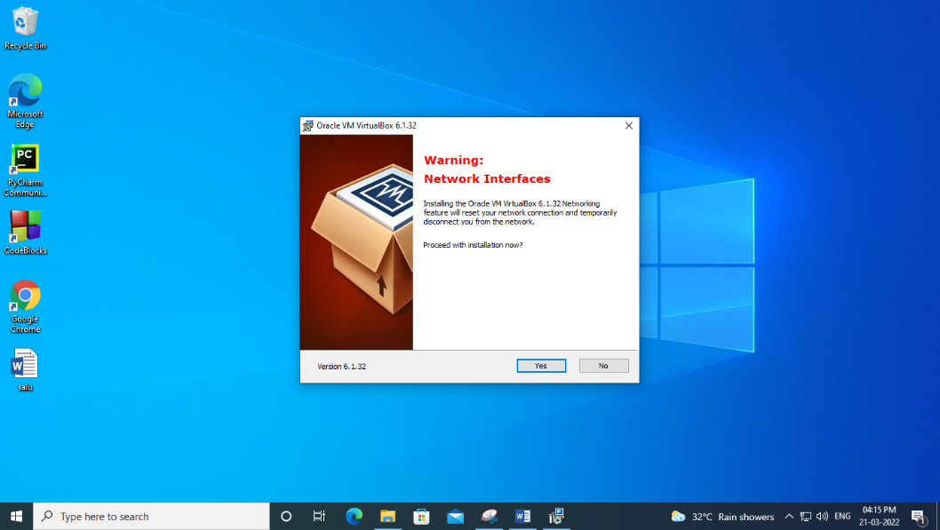

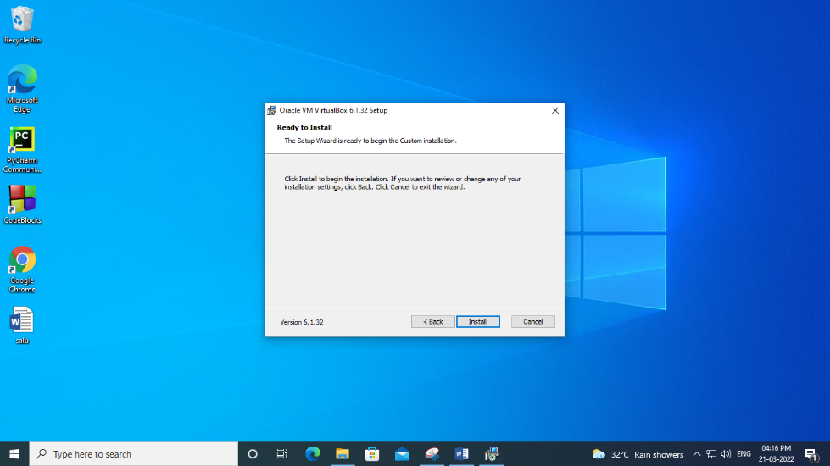

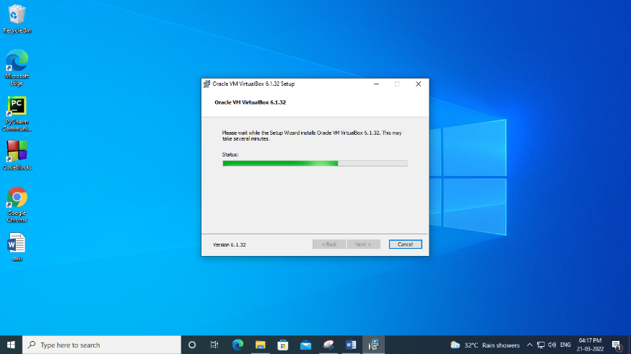

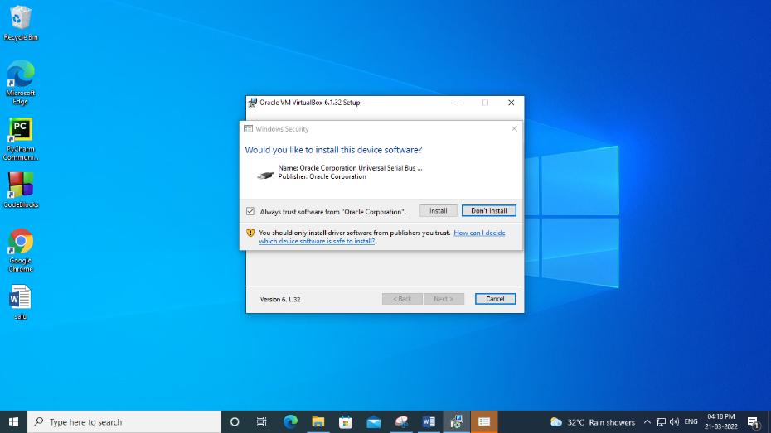

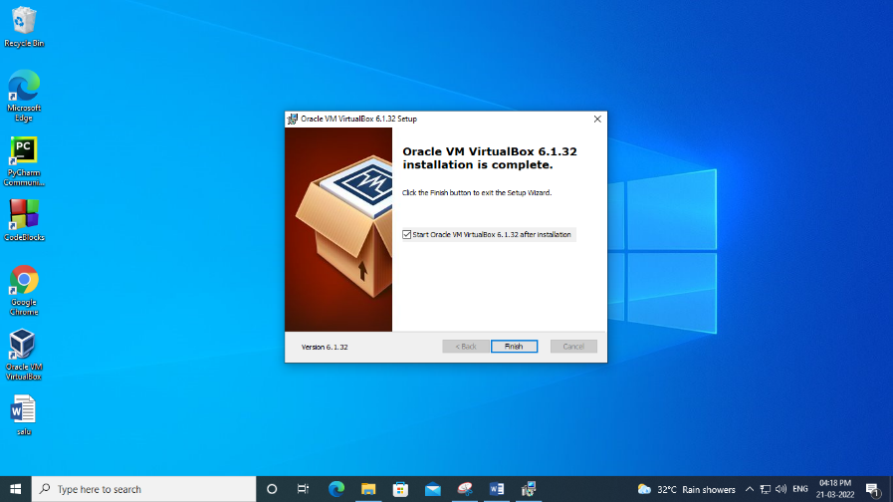

**Step 2:** Open VirtualBox and select New in the top taskbar

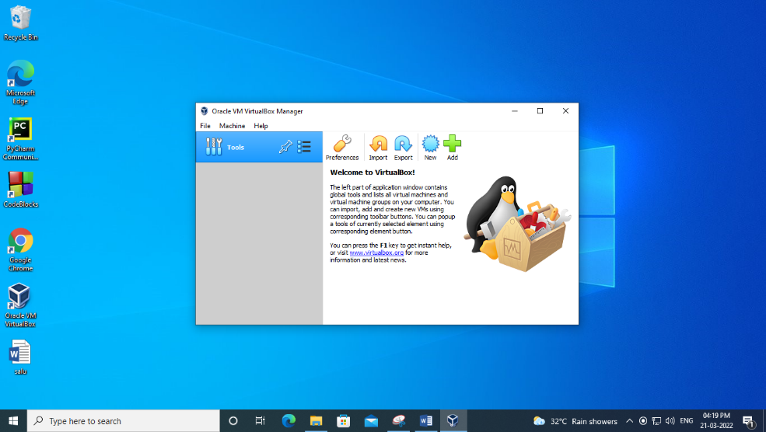

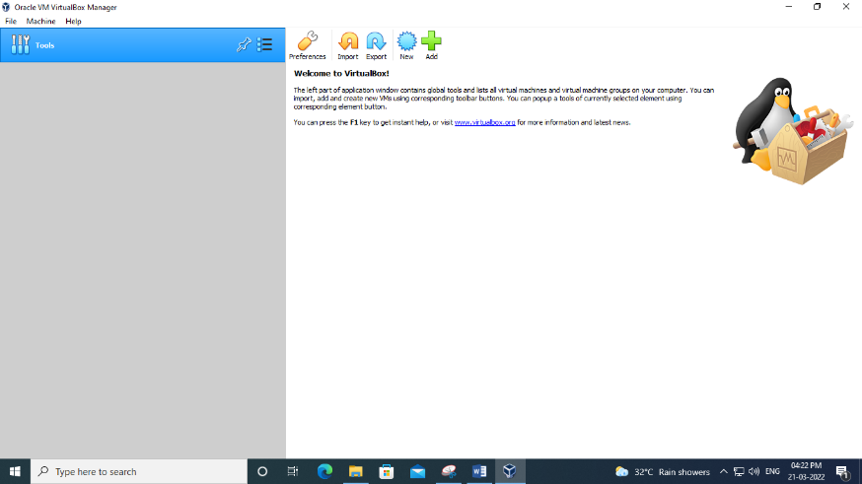

**Step 3:**Give your VM a name, choose Linux as the Type, then choose Ubuntu as the Version and select Next.

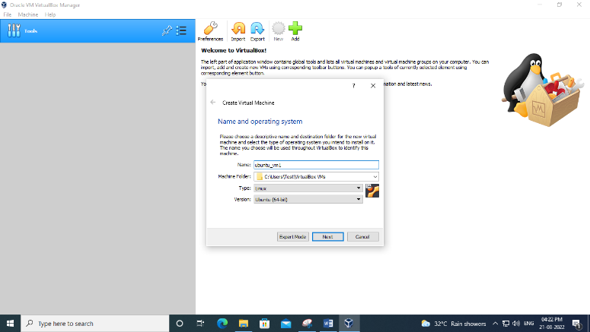

**Step 4:**Choose how much [RAM](https://www.lifewire.com/what-is-random-access-memory-ram-2618159) you want to assign to the virtual machine and select Next. The recommended minimum is 1024 [MB](https://www.lifewire.com/what-is-a-megabit-2483412)

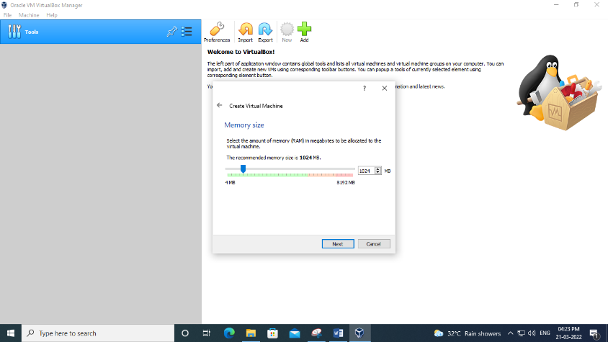

**Step 5:**Choose Create a virtual hard disk now and select Create

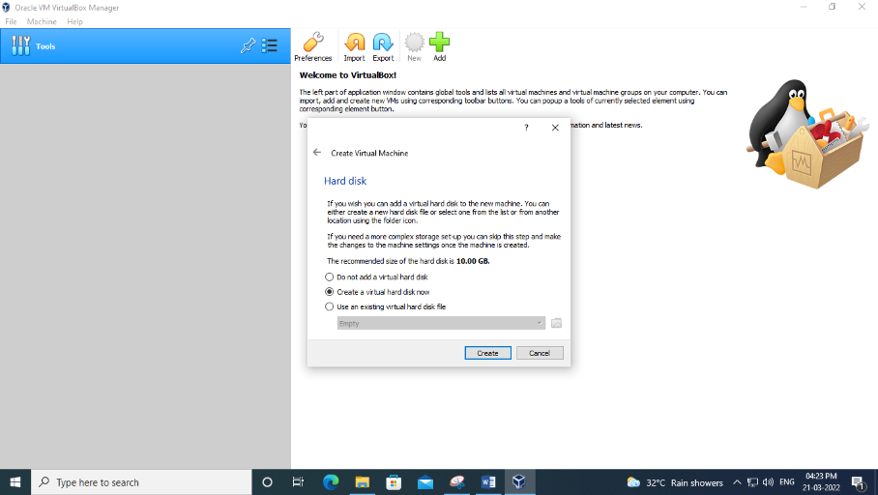

**Step 6:**Choose VDI (VirtualBox Disk Image) and select Next

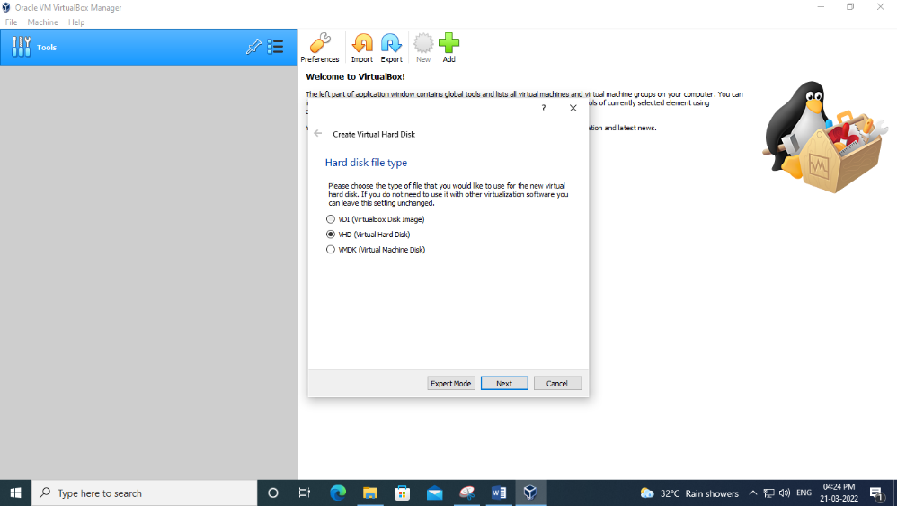

**Step 7:**Choose Dynamically allocated or Fixed size for the storage type and select Next

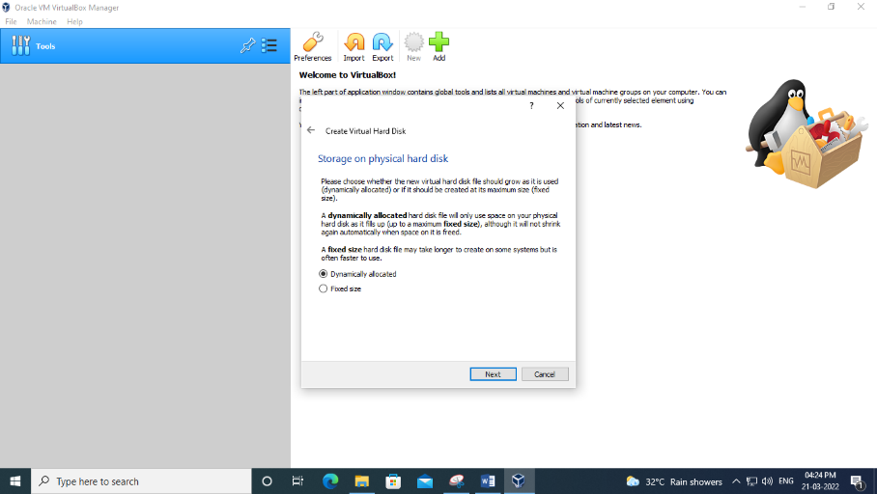

**Step 8:**Choose how much space you wish to set aside for Ubuntu and select Create.

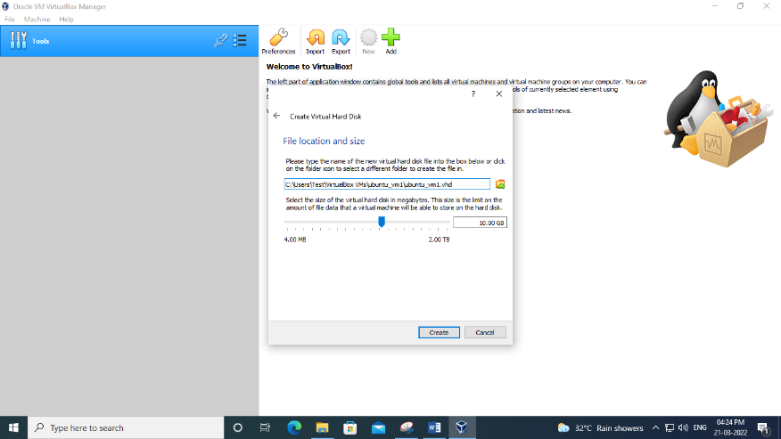

**Step 9:**The name of our virtual machine will now appear on the left side of the VirtualBox manager. Select Start in the toolbar to launch your VM.

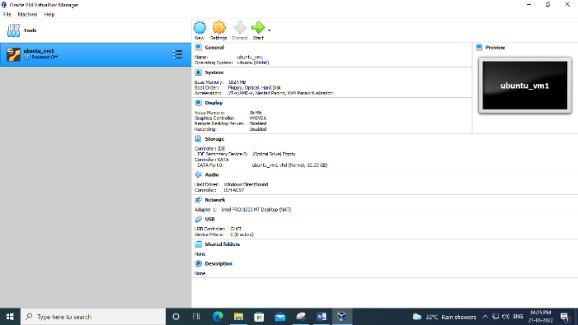

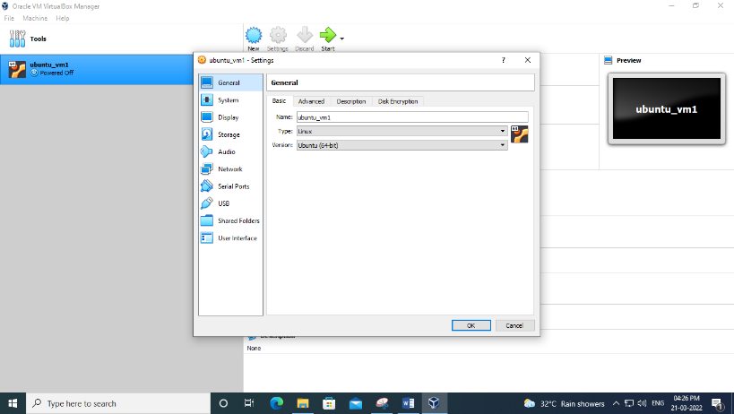

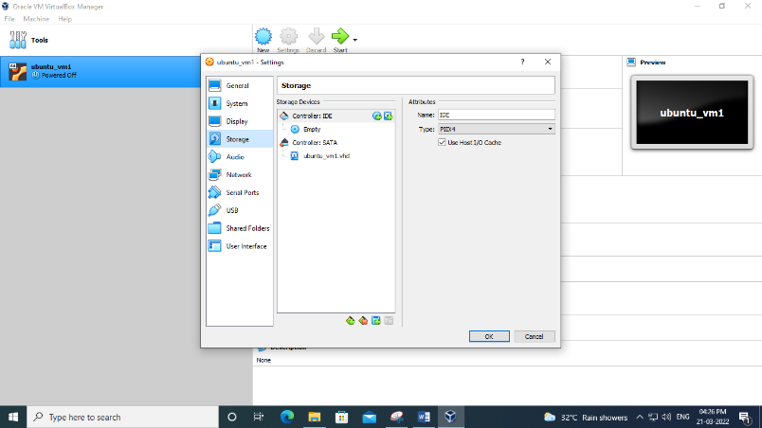

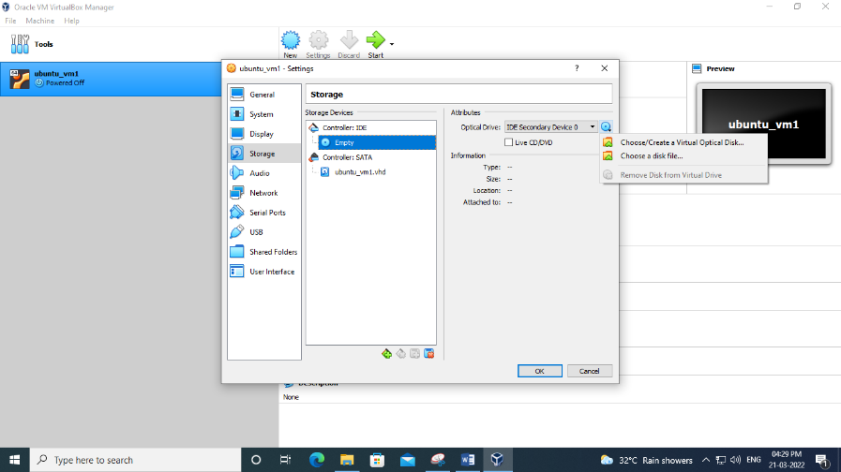

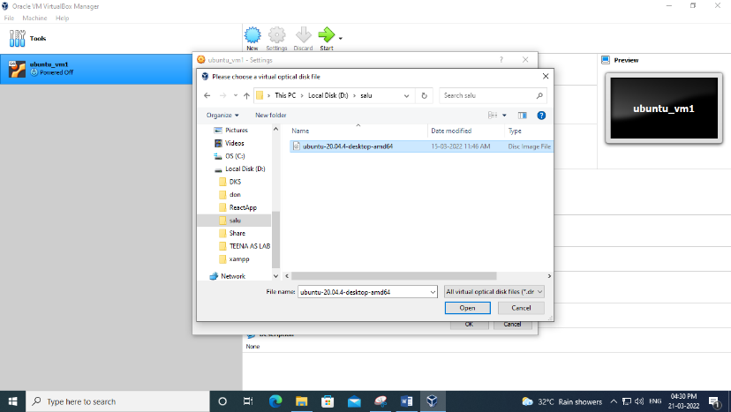

**Step 10:**VM will now boot into a live version of Ubuntu. Choose your language and select Install Ubuntu.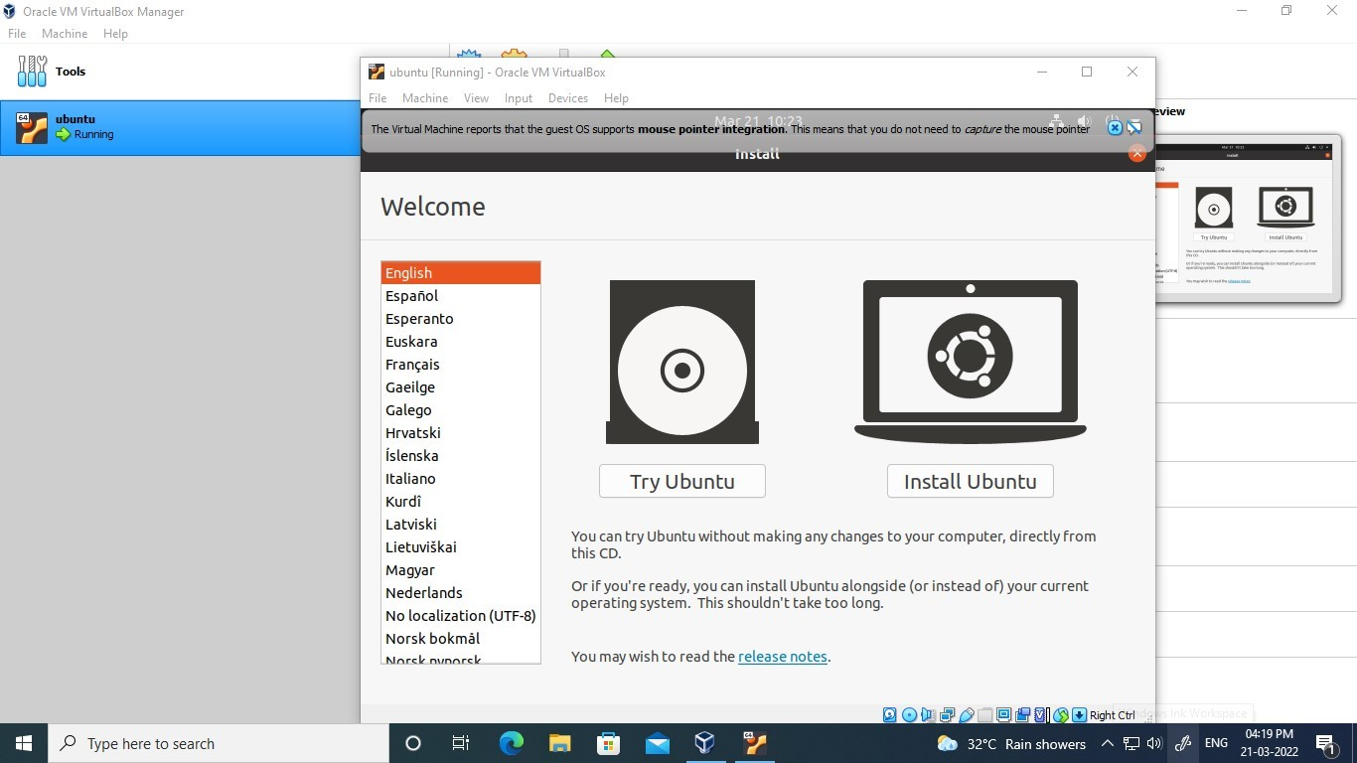

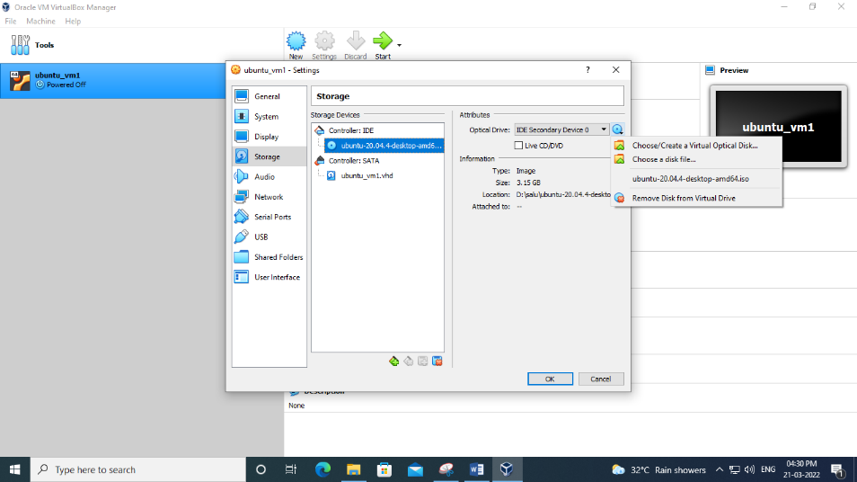

**Step 11:**Continue

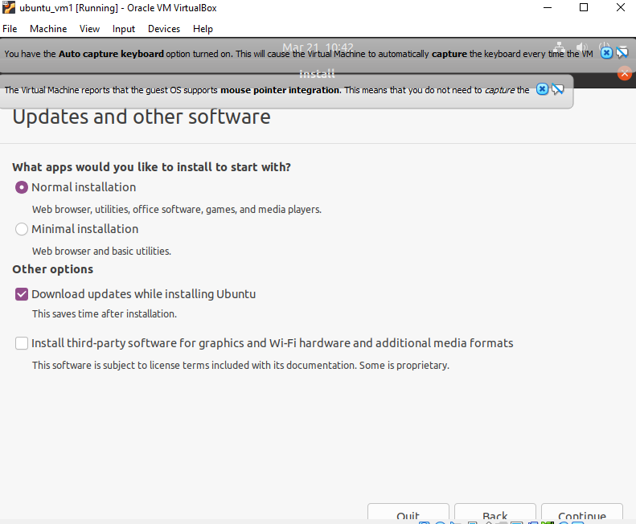

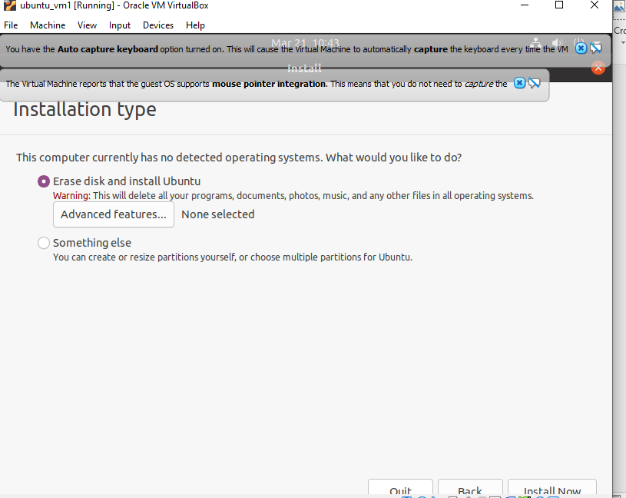

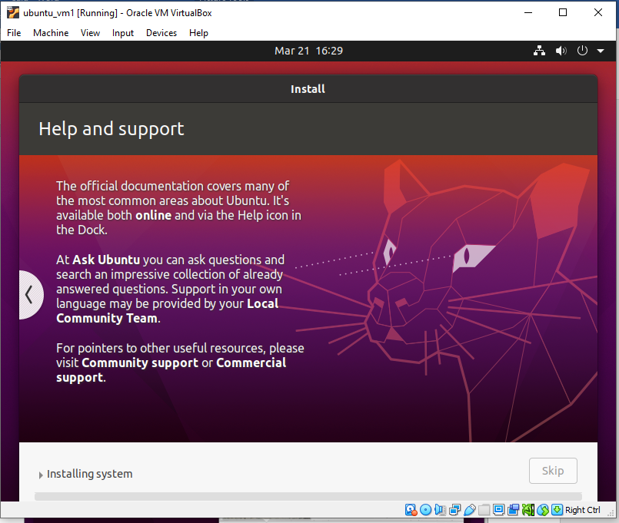

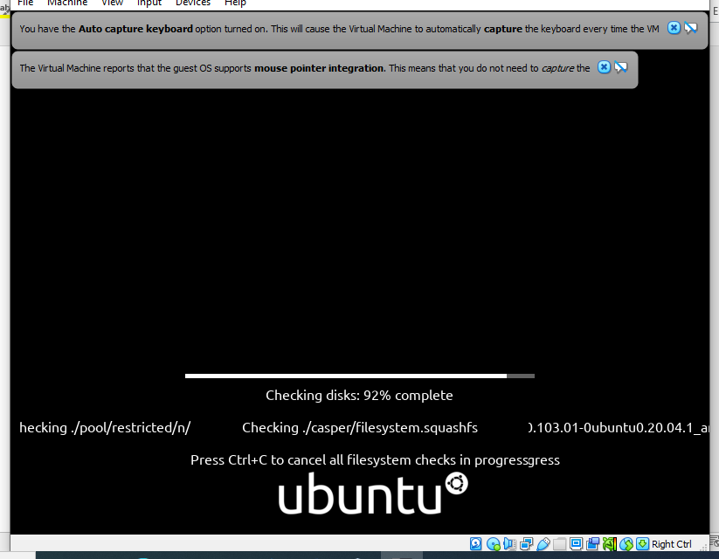

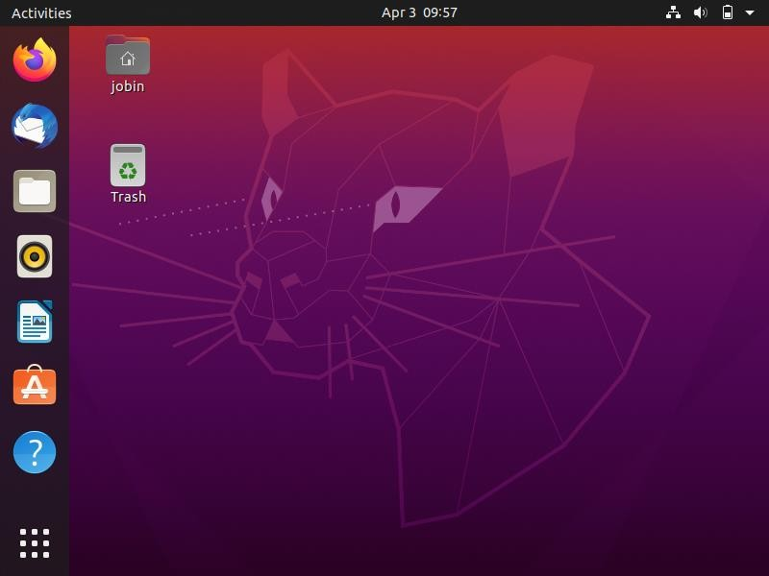

**NETWORKING & SYSTEM ADMINISTRATION LAB**

|  |
| --- |
| **Name: jobin t j**  **Roll No:7**  **Batch:MCA-B**  **Date:06-04-2022** |

**Experiment No: 3**

**Aim**

Study of a terminal based text editor such as Vim or Gedit, Basic Linux commands: - familiarity with following commands/operations expected

**Procedure**

**1.pwd**

This command is used to display the location of the current working directory.

Syntax :- $ pwd

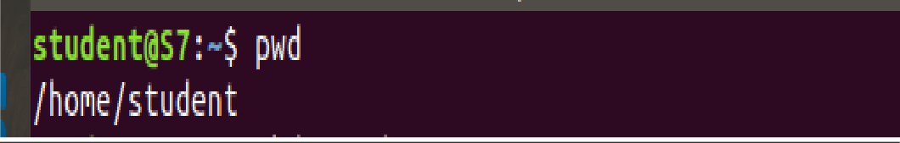

**2. mkdir**

This command is used to create a new directory under any directory.

Syntax :- $ mkdir<directory name>

Output :-



**3. ls**

This command is used to display a list of content of directory.

Syntax :- $ ls

Output :-

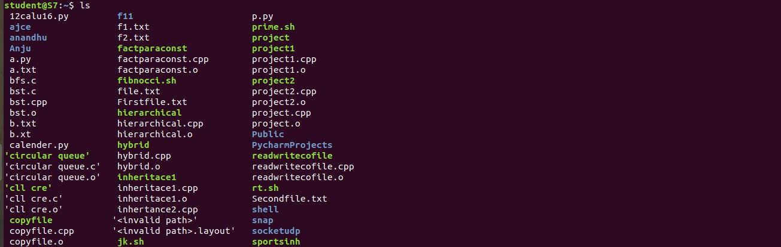

**4. man**

This command is used to display the user manual of any command that we can run on the terminal.

Syntax :- $ man <command name>

Output :-

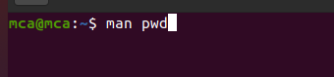

**5. ls –l** This command is used to shows file or directory, size, modified date and time, file or folder name and owner of the file, and its permission.

Syntax :- $ ls –l

Output:-

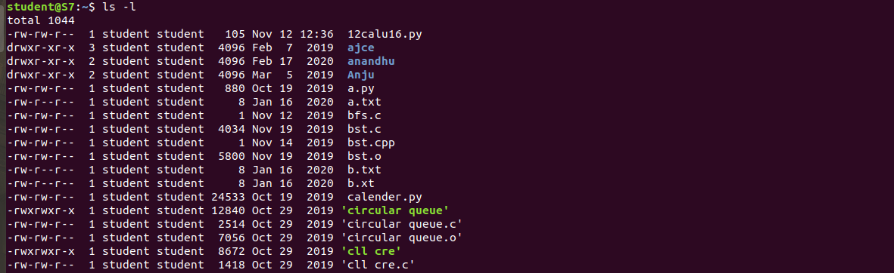

**6. ls –r**

This command is used to display files and directories in reverse order.

Syntax :- $ls –r

Output :-

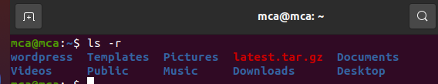

**7. ls –a**

This command is used to list all files including hidden files.

Syntax :- $ls –a

Output :-

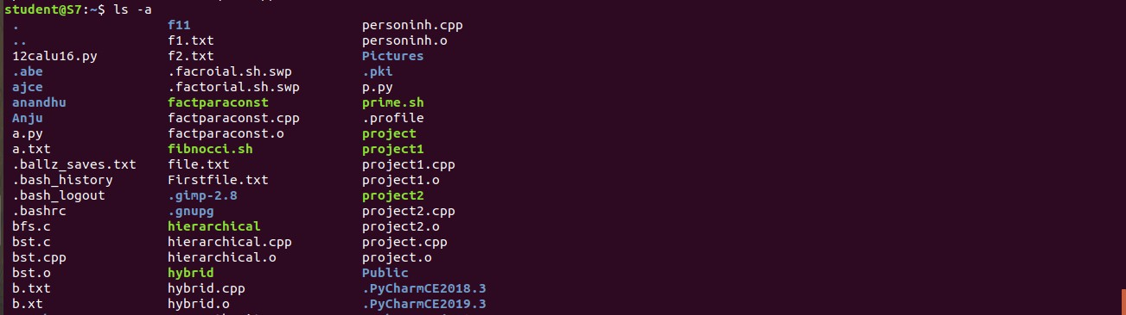

**8. ls –al**

This command is used to

Syntax :- $ ls -al

Output :-

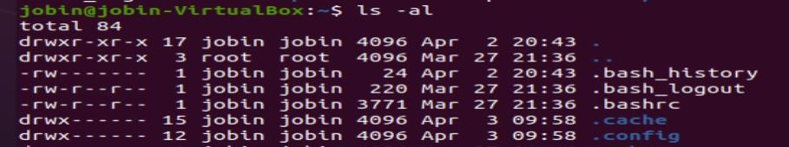

**9. ls –t**

This command is used to display files in the last modified order.

Syntax :- $ ls –t

Output :-



**10. cd**

This command is used to change the current directory.

Syntax :- $ cd <directory name>

 Output :-

**11. cd ..**

This command is used to move to the parent directory of current directory, or the directory one level up from the current directory.

Syntax :- $ cd ..

 Output :-

**12. cd –**

This command is used to switch back to previous directory we were working earlier.

Syntax :- $ cd –

Output :-

**13. cat > filename**

This command is used to create a file and add contents to that file.

Syntax :- $ cat > filename.txt

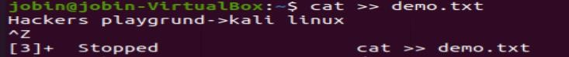 Output :-

**14. cat filename1 > filename2**

This command is used to copy the content from one file to another file.

Syntax :- $ cat filename1 > filename2

Output :-

**15. cat -n**

This command return contents with line numbers.

**Syntax**:- $ cat -n filename

**Output**:-



**16. cat -b**

This Returns contents with line numbers but excludes the empty lines

**Syntax**:- $ cat -b filename

**Output**:-



**17. touch**

This command is used to create a empty file

**Syntax**:- $ touch filename

**Output**:-

**18. echo command >> filename**

This command helps to add lines on the empty file

**Syntax**:- $ echo command>> filename

**Output**:-



**19. head**

This command returns first 10 lines in the file

**Syntax**:- $ head filename

**Output**:-

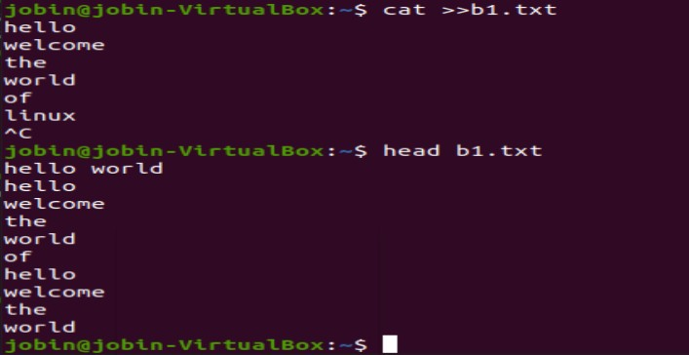

**20. head – (No. of lines)**

This will return beginning lines specified in the command

**Syntax**:- $ head -4 filename

**Output**:-

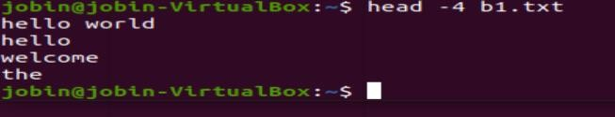

**21. tail**

This returns the last 10 lines in the file

**Syntax** $ tail filename

**Output**:-

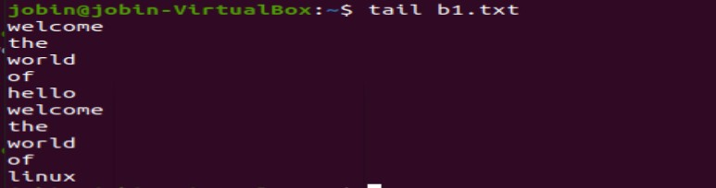

**22. tail – (No. of lines)**

This will return last no of lines specified in the command

**Syntax**:- $ tail -4 filename

**Output**:-

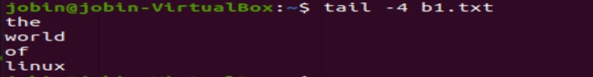

**23. cut -d -f2**

This commands in Linux allows you to select the second part of the content that split by ‘ - ‘ delimiter.

**Syntax**:- $ cut -d- f2 filename

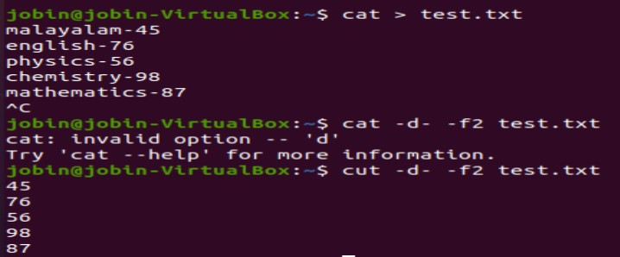**Output**:-

**24. cut -d -f1**

This commands in Linux allows you to select the First part of the content that split by ‘ - ‘ delimiter.

**Syntax**:- $ cut -d- f1 filename

**Output**:

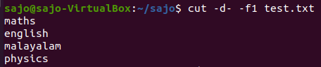

**25. cut -d ‘ ‘ f2**

This commands in Linux allows you to select the second part of the content that split by ‘ ‘ delimiter.

**Syntax:-** $ cut -d ‘ ‘ f2 filename.txt

**Output:-**

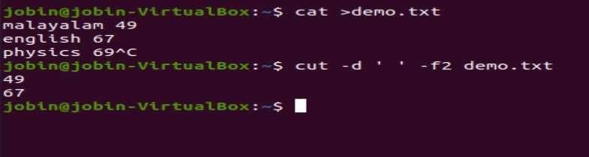

**26. cut -b 2**

This command in Linux allows to select only these bytes.

**Syntax:-** $ cut -b 2 filename

**Output:-**

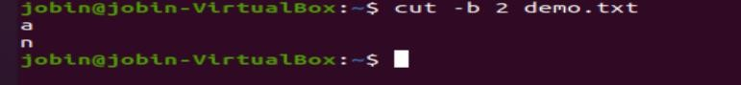

**27.** **cut –complement**

This command helps to exclude given bytes.

**Syntax:-** $ cut –complement -c 1 filename

**Output:-**

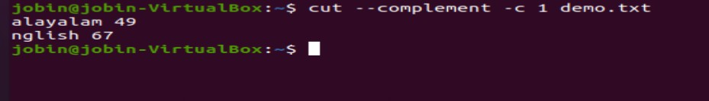

**28. paste**

This command helps to paste contents to other file

**Syntax:-** $ paste filename > filename2

**Output:-**



**29. paste a b > c**

This command helps to paste from multiple files.

**Syntax:-** $ paste file1 file2 > file3

**Output:-**

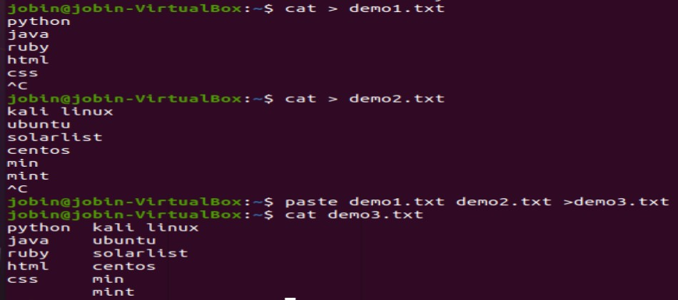

**30. paste -d ‘ ‘**

This command helps to paste contents with ‘ ‘ delimiter.

**Syntax:-** $ paste -d ‘ ‘ file1 file 2 > file3

**Output:-**

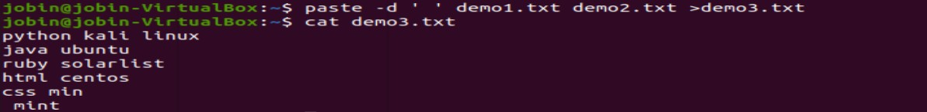

**31. paste -d ‘-‘**

This command helps to contents from multiple files with ‘-‘ delimiter.

**Syntax:-** $ paste -d ‘-‘ file1 file2 > file3

**Output:-**

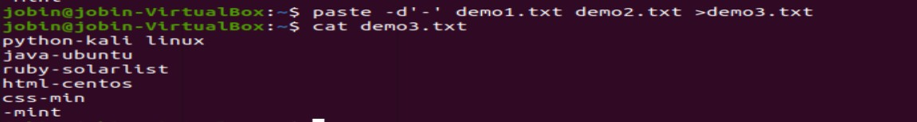

**32. paste -s**

This command helps to paste on file at a time instead of in parallel.

**Syntax:-** $ paste -s file1 file2 > file3.

**Output:-**



**33. more**

More command is used to view the text files in the command prompt, displaying one screen at a time in case the file is large.

**Syntax:-** $ more filename.

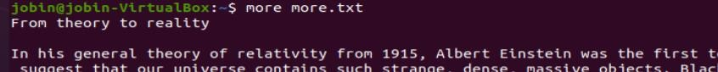**Output:-**

**SPACE Key** is act as a NEXT button.

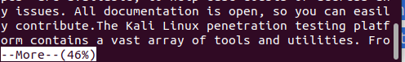

**B Key** act as a PREVIOUS button.

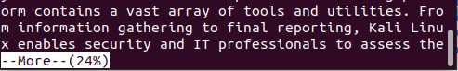

**ENTER** **key** is used to view line by line.

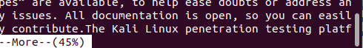

**34. more -s**

This command is used to squeeze multiple blank lines into one.

**Syntax:-** $ more -s filename.

**Output:-**

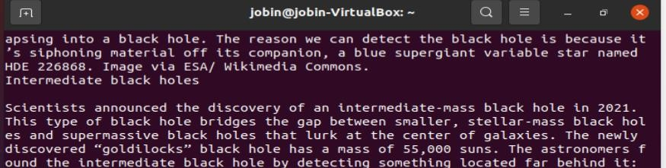

**35. more –(no.)**

This command helps to view content based on specified number of lines.

**Syntax:-** $ more -4 filename.

**Output:-**

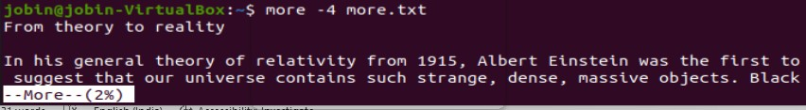

**36.cp**

cp command used to copy .

**Syntax:-** .$cp filename1.txt filename2.txt

**output:**

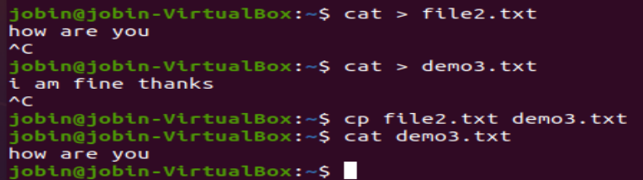

**37.cp -r**

cp -r command is used to copy entire directory.

**Syntax:-** $cp -r directory1 directory2

**output:**



**38.$cp -i**

this command is used to ask permission to overwrite

**Syntax:-** $cp -i filename.txt directory

**output :**



**39.$mv**

mv command is used to move a file to another directory

**Syntax:-** .$mv filename.txt directory

**output:**

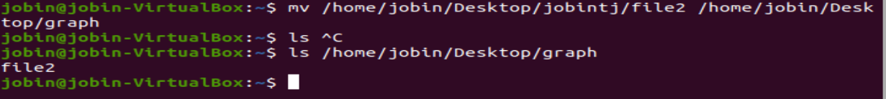

**40.$mv -i**

this command is used to ask permission to move one directory to anotherdirectory .

**Syntax:-** .$mv -i filename.txt directory

**output:**

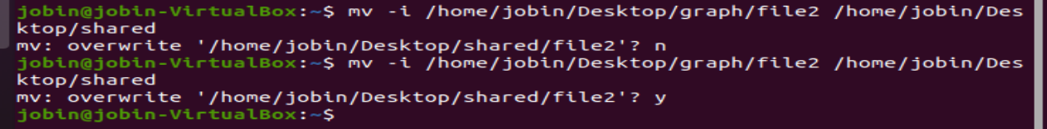



**41.read**

The Linux **read** command is used to read the contents of a line into a variable.

**Syntax:-** $read variable_name

**Output:**-

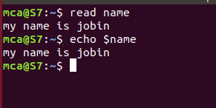

**42.locate**

The locate command and [find](https://www.javatpoint.com/linux-find)command is used to search a file by name. But, the difference between both commands is that locate command is a background process and searches the file in the database whereas, find command searches in the filesystem. The locate command is much faster than find command.

**Syntax:-** $locate filename.txt

**Output:-**



**43.locate -i**

It is used to ignore case sensitivity of the specified patterns.

**Syntax :-** $locate -i filename.txt

**Output:**-

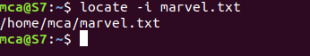

**44.find**

The find command helps us to find a particular file within a directory. It is used to find the list of files for the various conditions like permission, user ownership, modification, date/time, size, and more.

**Syntax :-** $find filename.txt

**Output:-**

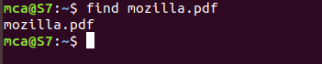

**45.grep**

The 'grep' command stands for **"global regular expression print"**. grep command filters the content of a file which makes our search easy.

**Syntax:-** $grep word filename.txt

**Output:-**

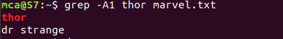

**46.grep -i**

The 'grep -i' command filters output in a case-insensitive way.

**Syntax:-** $grep -i word filename.txt

**Output:-**



**47.grep -v**

The 'grep -v' command displays lines not matching to the specified word.

**Syntax:-** $grep -v word filename.txt

**Output:-**

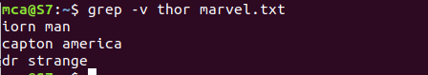

**48.grep -A**

grep -A command is used to display the **line after the result**.

**Syntax:-** $grep -A word file.txt

**Output:-**



**49.grep -B**

grep -B command is used to display the **line before the result**.

**Syntax:-** $grep -B word file.txt

**Output:-**

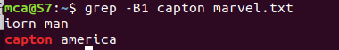

**50.grep -C**

grep -C command is used to display the **line after and line before** the result.

**Syntax:-** $grep -C word file.txt

**Output:-**

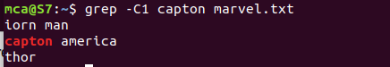

**51.df**

Linux df command is used to display the **disk space used in the file system**. The 'df' stands for **"disk filesystem**." It defines the number of blocks used, the number of blocks available, and the directory where the file system is mounted.

**Syntax:-** $df

**Output:-**

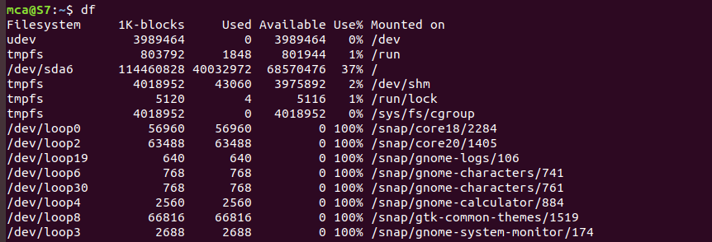

**52.df -m**

it is used to see the report in mega byte

**Syntax:-** $df -m

**Output:-**

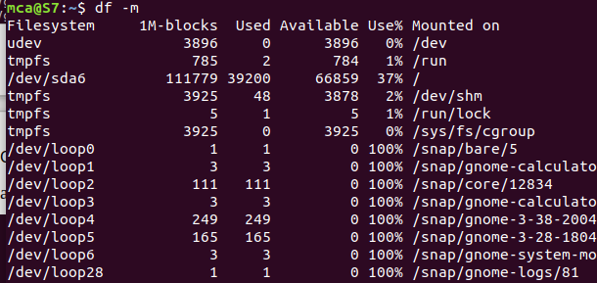

**53.du**

To check how much space a file or directory take.

**Syntax:-** $du

**Output:-**



**54.wc**

Linux wc command helps in counting the lines, words, and characters in a file. It displays the number of lines, number of characters, and the number of words in a file. Mostly, it is used with pipes for counting operation.

**Syntax :-** $wc filename.txt

**Output:-**

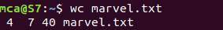

**-l, --lines:** It is used to print the newline counts.

**-w, --words:** It is used to print the word counts.

**-c, --bytes:** It is used to print the byte counts.

**-m, --chars:** It is used to print the character counts.

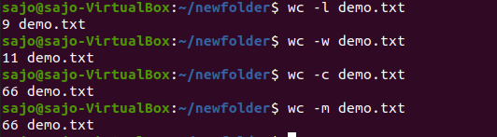

**55.useradd & passwd**

useradd is a command in Linux that is used to add user accounts to your system

passwd command in Linux is used to change the user account passwords. The root user reserves the privilege to change the password for any user on the system, while a normal user can only change the account password for his or her own account.

**Syntax:-** $ sudo useradd user1

$ sudo passwd user1

**Output:-**



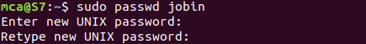

**56.groupadd**

groupaddcommand is used to create a new user group.

**Syntax:-** groupadd [option] group_name

**Output:-**



**57.usermod**

usermod command or modify user is a command in Linux that is used to change the properties of a user in Linux through the command line

**Syntax:-** $sudo usermod [option] groupname username

**Output:-**



**58.compgen**

compgen is a bash built-in command which is used to list all the commands that could be executed in the Linux system. This command could also be used to count the total number of commands present in the terminal or even to look for a command with the specific keyword.

**Syntax:-** $compgen -g

**Output:-**

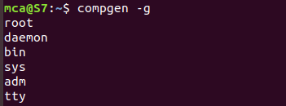

**59.userdel**

userdel command in Linux system is used to delete a user account and related files. This command basically modifies the system account files, deleting all the entries which refer to the username LOGIN. It is a low-level utility for removing the users.

**Syntax:-** sudo userdel username

**Output:-**

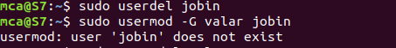

**60.groupdel**

*groupdel*command is used to delete a existing group. It will delete all entry that refers to the group, modifies the system account files, and it is handled by superuser or root user.

**Syntax:-** $sudo groupdel groupname

**Output:-**



**61.chmod**

the chmod command is used to change the access mode of a file.  
The name is an abbreviation of change mode.

**Syntax:-** $chmod permission filename

**Output:-**



**62.chown**

chown command is used to change the file Owner or group. Whenever you want to change ownership you can use chown command.

**Syntax:-** sudo chown username filename

**Output:-**

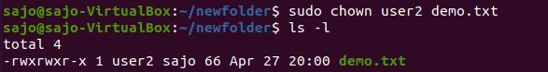

**NETWORKING & SYSTEM ADMINISTRATION LAB**

|  |
| --- |
| **Name: jobin t j**  **Roll No:7**  **Batch:MCA-B**  **Date:06-04-2022** |

**Experiment No: 4**

**Aim**

Shell scripting: study bash syntax, environment variables, variables, control constructs such as if, for and while, aliases and functions, accessing command line arguments passed to shell scripts.

**Program:1**

Shell program to print a value

**Procedure**

#!/bin/bash

echo "10"

echo “enter the value”

read a

echo “the entered value is : “ $a

**Output**

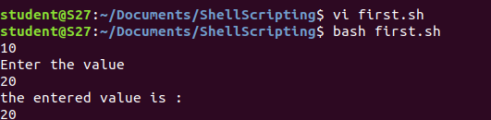

**Program:2**

Shell program to add 2 numbers

**Procedure**

#!/bin/bash

echo "enter the value 1"

read a

echo "enter the value 2"

read b

d=$(($a + $b))

echo "sum="$d

**Output**

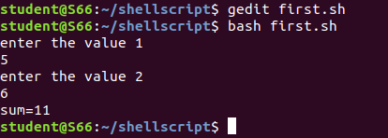

**Program:3**

Shell program to check largest of 2 numbers

**Procedure**

#!/bin/bash

echo "enter 2 numbers"

read a

read b

echo $a $b

if [ $a -gt $b ]

then

echo "$a is greater"

else

echo "$b is greater"

fi

**Output**

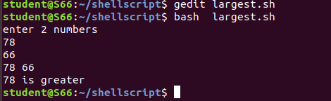

**Program:4**

Shell program to check largest of 3 numbers

**Procedure**

#!/bin/bash

echo "enter 3 numbers"

read a

read b

read c

if [ $a -gt $b  -a  $a -gt $c ]

then

echo "$a is greater"

elif [ $b -gt $a  -a  $b -gt $c ]

then

echo "$b is greater"

else

echo "$c is greater"

fi

**Output**

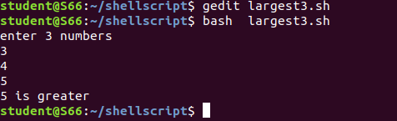

**Program:4**

Shell program to check given number is odd or even

**Procedure**

#!/bin/bash

echo "enter the value"

read a

if [ $(($a % 2)) -eq 0 ]

then

echo "even"

else

echo "odd"

fi

**Output**

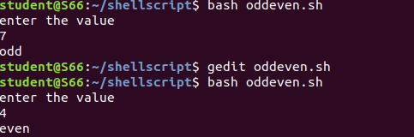

**Program:5**

Write a shellscript to display current date and calendar

**Procedure**

#!/bin/bash

echo " Todays date="

echo $(date)

echo "Calender="

cal

**Output**

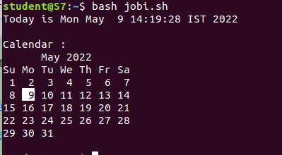

**Program:6**

Write a shellscript to check a number is greater than or less than or equal to another number

**Procedure**

#!/bin/bash

echo "enter the two numbers"

read a

read b

if [ $a -gt  $b ]

then

echo " $a is greater than $b"

elif [ $a -lt  $b ]

then

echo "$a is less than $b"

elif [ $a -eq  $b ]

then

echo "$a is equal to $b "

else

echo "invalid"

fi

**Output**

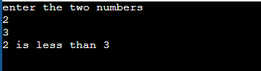

**Program:7**

Find the sum of first 10  numbers

**Procedure**

#!/bin/bash

i=1

summ=0

while [ $i -le 10 ]

 do

   summ=$((summ+i))

    i=$((i+1))

 done

echo "sum of first 10 numbers = $summ"

**Output Screenshot**

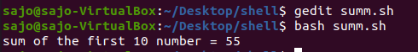

**Program:8**

Write a shellscript to find the sum ,average and product of 4 numbers

**Procedure**

#!/bin/bash

echo "enter 4 numbers"

read a

read b

read c

read d

sum1=$((a+b+c+d))

p=`expr $a \* $b \* $c \* $d`

avg=$((sum1/4| bc -l))

echo "Sum=$sum1"

echo "product= $p"

echo "average=$avg"

**Output**

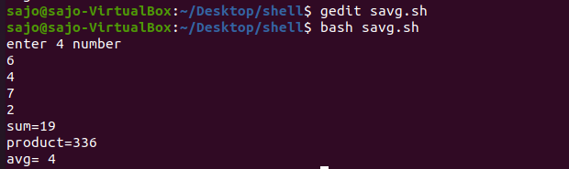

**Program:9**

Find the factorial of the given number

**Procedure**

#!/bin/bash

fact=1

echo "enter the number"

read n

for (( i=2 ; i<=n ; i++ ))

do

fact=`expr $fact \* $i`

done

echo $fact

**Output**

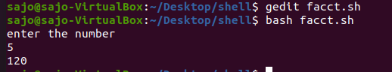

**Program:10**

Find the palindrome of a given number

**Procedure**

#!/bin/bash

echo "enter the number"

read n

a=$n

rev=0

while [ $n -gt 0 ]

do

r=$((n%10))

rev=`expr $rev \* 10 + $r`

n=`expr $n / 10 `

done

if [ $a -eq  $rev ]

then

echo "palindrome"

else

echo "not palindrome"

fi

**Output**

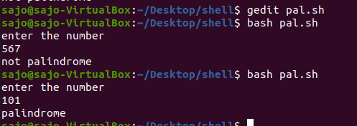

**Program:11**

Check whether the given year is leap year or not

**Procedure**

#!/bin/bash

echo "enter the year"

read y

if [ $((y%4)) == 0 ]  &&  [  $((y%100)) != 0 ]  ||  [  $((y%400)) == 0  ]

 then

 echo "$y is a leap year"

 else

 echo "$y is not a leap year"

 fi

**Output**

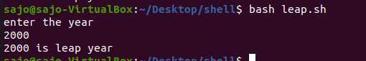

**Program:11**

Write a shellscript program to find the sum of all the digits in a number

**Procedure**

#!/bin/bash

echo "Enter the number"

read a

while [ $a -ne 0 ]

do

r=$((a%10))

s=$((s+r))

a=$((a/10))

done

echo "Sum of digit = "$s

**Output**

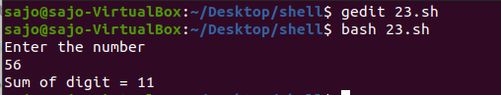

**Program:11**

Write a shellscript program to find the sum  and average of numbers in command line

**Procedure**

#!/bin/bash

i=0

echo "enter the size"

read n

echo "enter the numbers"

while [ $i -lt $n ]

do

 read a

sum=$((sum+a))

avg=$((sum/n))

i=$((i+1))

done

echo "sum=$sum"

echo "average= $avg"

**Output**

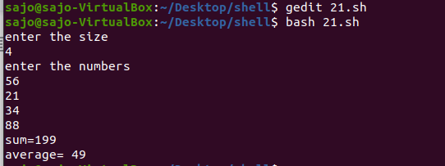

**Program:11**

Write a shellscript program to  do mathematical calculations using switch case

**Procedure**

#!/bin/bash

echo "enter two number"

read a

read b

echo " 1.Addition "

echo " 2.Substraction "

echo " 3.Multiplication  "

echo "4.Division"

echo "5.Exit"

s=1

while [ $s == 1 ]

do

echo "Enter the choice"

read ch

case $ch in

1)

echo "sum= "$((a+b))

;;

2)

echo "Substraction="$((a-b))

;;

3)

echo "Multiplication="$((a*b))

;;

4)

echo "divison="$((a/b))

;;

5)exit

;;

*)

echo "invalid"

;;

esac

done

**Output**

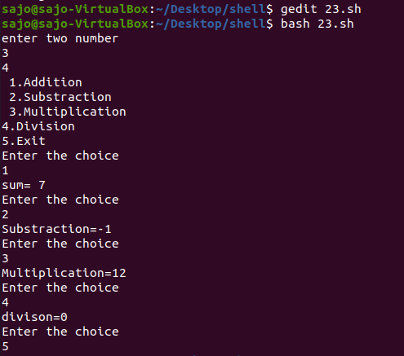

**NETWORKING & SYSTEM ADMINISTRATION LAB**

|  |
| --- |
| **Name: jobin t j**  **Roll No:7**  **Batch:MCA-B**  **Date:06-04-2022** |

**Experiment No: 5**

**Aim**

Install Linux, Apache, MySQL, PHP (LAMP) stack on Ubuntu 18.04

**Procedure**

**INSTALLING APACHE**

**Step 1** : Installing Apache and Updating the Firewall

The Apache web server is a popular open source web server that can be used along with PHP to host dynamic websites.

First, make sure your apt cache is updated with:

Syntax: $ sudo apt update

**Output:**

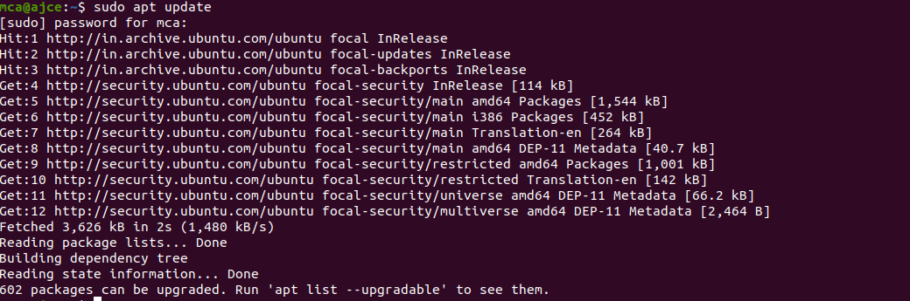

**Step 2** : Install Apache 2

Once the cache has been updated, you can install Apache with:

Syntax: $ sudo apt update

Press Y and hit ENTER to confirm, and the installation will proceed.

**Output:**

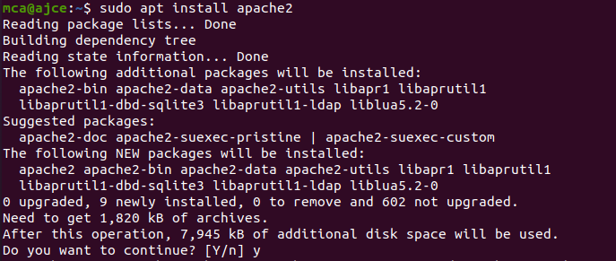

**Step 3** : Adjust the Firewall to Allow Web Traffic

Next, assuming that you have followed the initial server setup instructions and enabled the UFW firewall, make sure that your firewall allows HTTP and HTTPS traffic. You can check that UFW has an application profile for Apache.

**Output:**

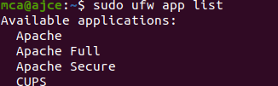

**Step 4** : Check Apache Full

Apache Full profile details, you’ll see that it enables traffic to ports 80 and 443:

Syntax: sudo ufw app info "Apache Full"

**Output:**

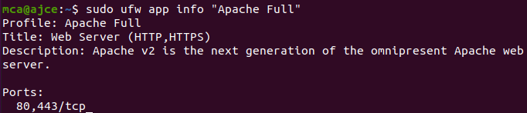

To allow incoming HTTP and HTTPS traffic for this server, run

Syntax: sudo ufw allow "Apache Full"

**Output:**

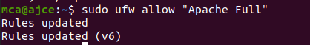

**Step 5** : A spot check right away to verify that everything went as planned by visiting your server’s public IP address in your web browser

**Output:**

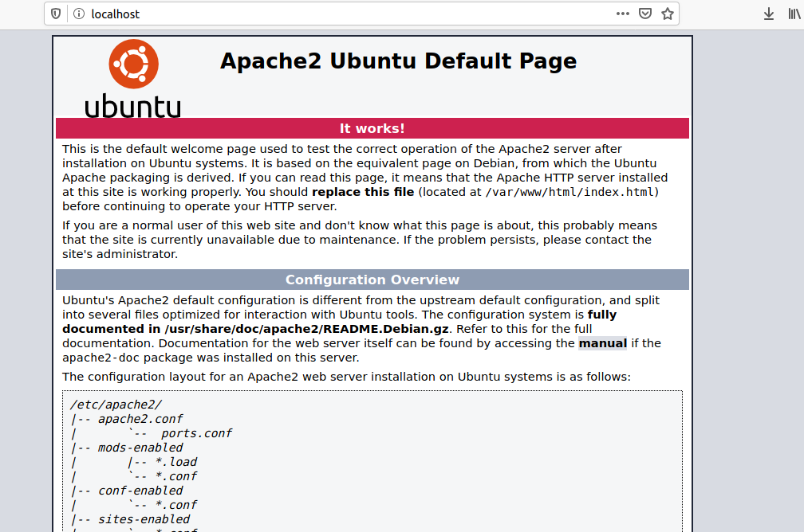

**Installing MySQL**

**Step 1** : In this case, you do not have to run sudo apt update prior to the command. This is because you recently ran it in the commands above to install Apache. The package index on your computer should already be up-to-date.

Syntax: $ sudo apt install mysql-server

**Output:**

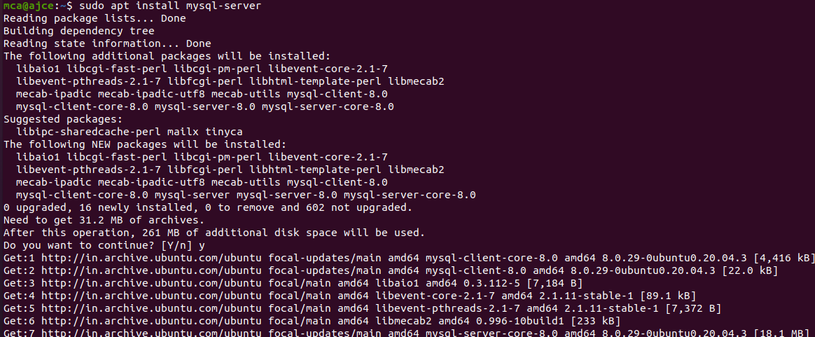

**Step 2** :

This will connect to the MySQL server as the administrative database user root, which is inferred by the use of sudo when running this command.

Syntax: $ sudo mysql

**Output:**

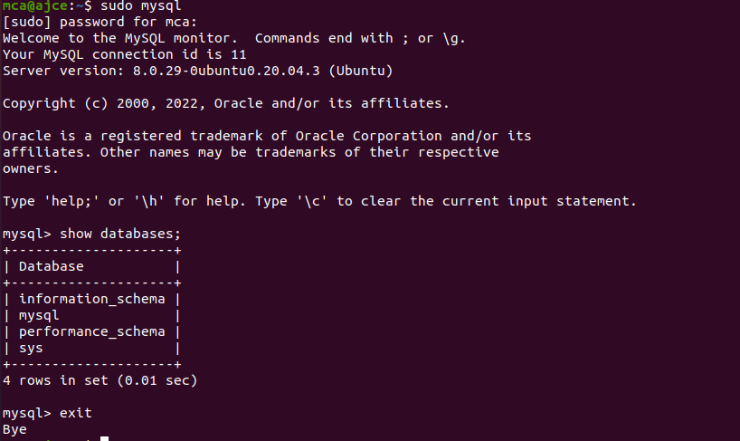

**Installing PHP**

In addition to the php package, you’ll also need libapache2-mod-php to integrate PHP into Apache, and the php-mysql package to allow PHP to connect to MySQL databases. Run the following command to install all three packages and their dependencies.

**Step 1** : Installation

Syntax: sudo apt install php libapache2-mod-php php-mysql

**Output:**

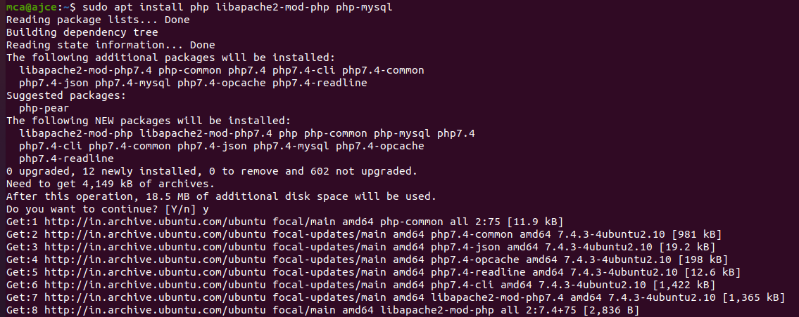

**Step 2** : Restart

Syntax: sudo systemctl restart apache2

**Output:**



**Step 3** : Testing PHP Processing on your Web Server

**Output:**



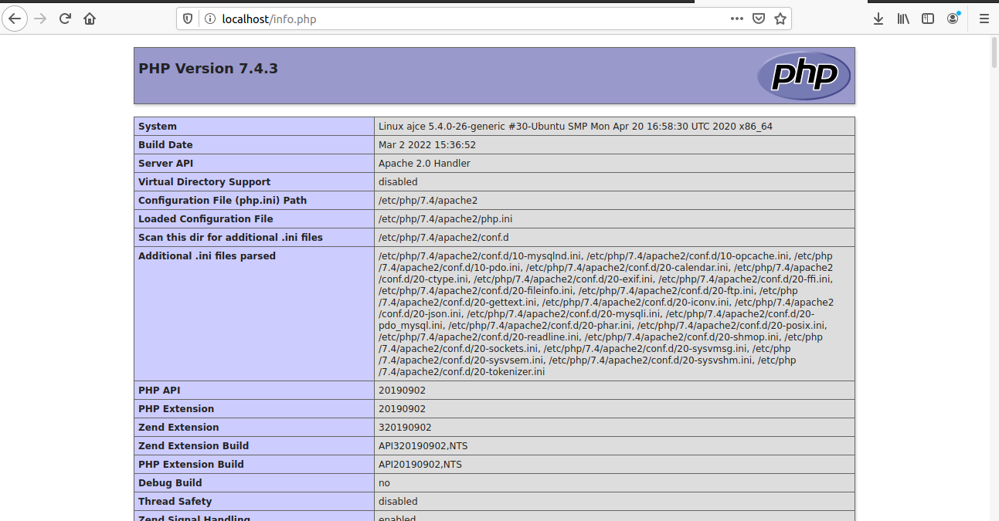

**Install WordPress with LAMP on Ubuntu 18.04**

**Step 1** : Download WordPress

Syntax: $ wget -c http://wordpress.org/latest.tar.gz

$ tar -xzvf latest.tar.gz

**Output:**

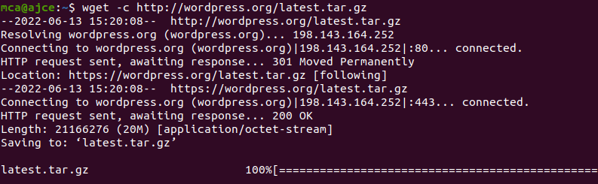

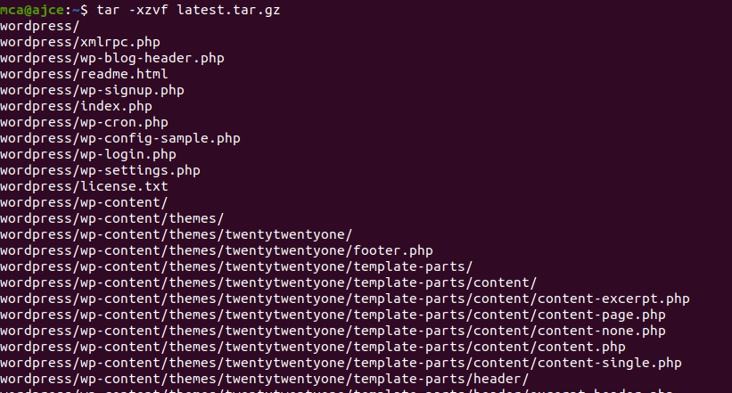

**Step 2** : Creating a MySQL Database and User for WordPress

The first step you’ll take is a preparatory one. Even though MySQL is already installed, you still need to create a database to manage and store the user information for WordPress to use. To get started, log into the MySQL root (administrative) account by issuing the following command:

Syntax: $ sudo mysql

You will be prompted for the password you set for the MySQL root account when you installed the software. However, if you have password authentication enabled for your root user, you can run the following command and enter your password information when prompted:

Syntax: $ mysql -u root –p

**Output:**

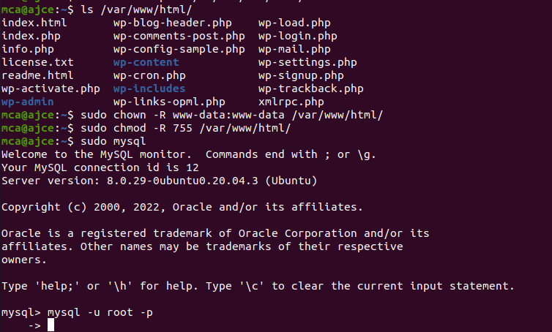

**Step 3** : Create the database for WordPress

**Output:**

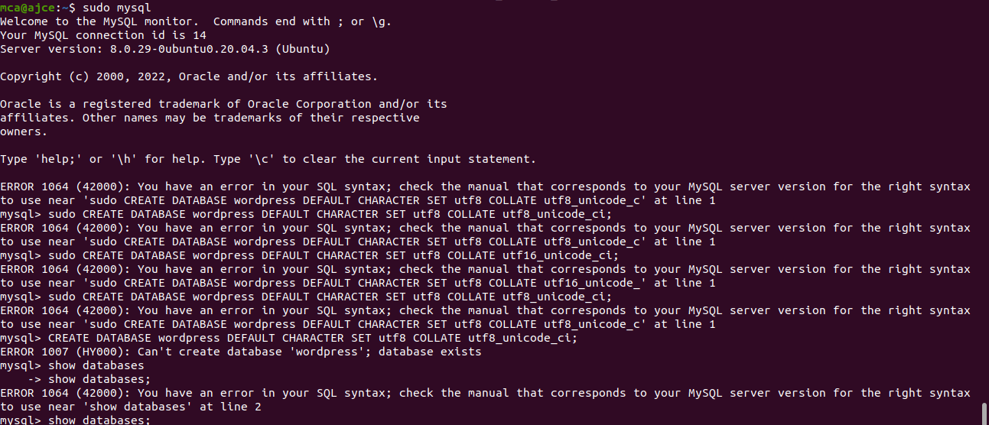

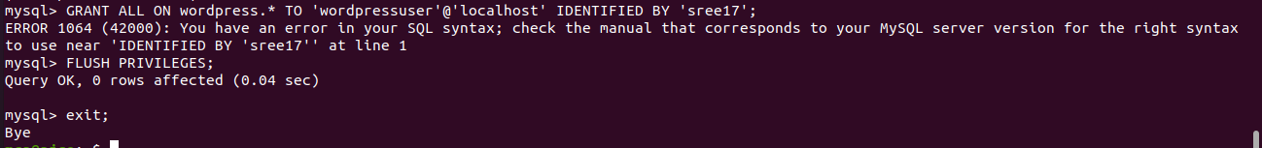

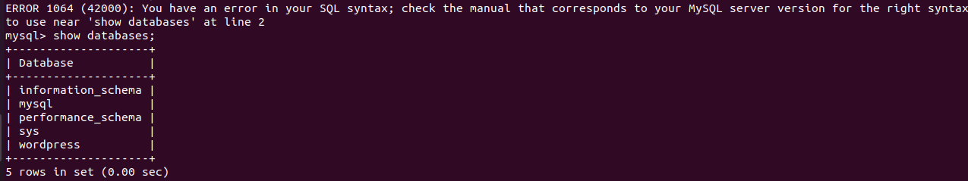

**Step 2** :

Go the /var/www/html/ directory and rename existing wp-config-sample.php to wpconfig.php. Also, make sure to remove the default Apache index page.

Syntax: sudo mv wp-config-sample.php wp-config.php

sudo rm -rf index.html

**Output:**

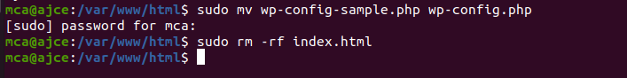

**Step 3** :

Then update it with your database information under the MySQL settings section (refer to the highlighted boxes in the image below): This setting can be added after the database connection settings, or anywhere else in the file:.

Syntax: define('DB_NAME', 'wordpress');

/** MySQL database username */

define('DB_USER', 'wordpressuser');

/** MySQL database password */

define('DB_PASSWORD', 'password');

. . .

define('FS_METHOD', 'direct');

**Output:**

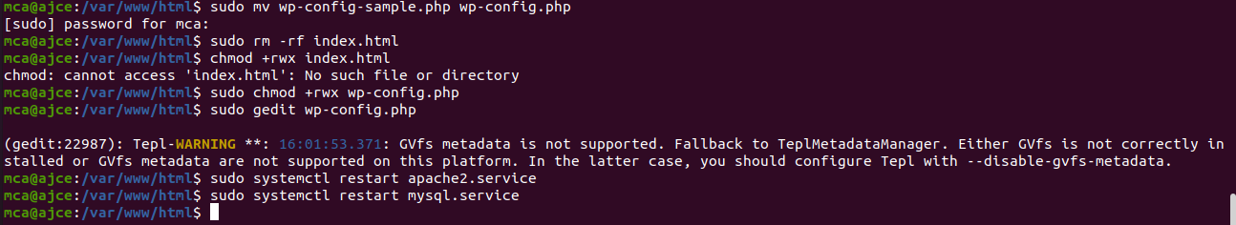

Save and close the file when you are finished.

**Step 4**: Restart the web server and mysql service

Syntax: $sudo systemctl restart apache2.service

$ sudo systemctl restart mysql.service

**Output:**

**Step 5**: Completing the Installation Through the Web Interface

The server configuration is complete, you can complete the installation through the web interface.In your web browser, navigate to your server’s domain name or public IP address

**Output:**

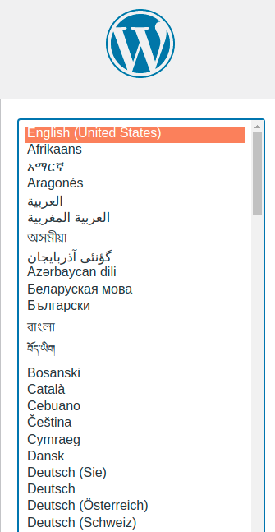

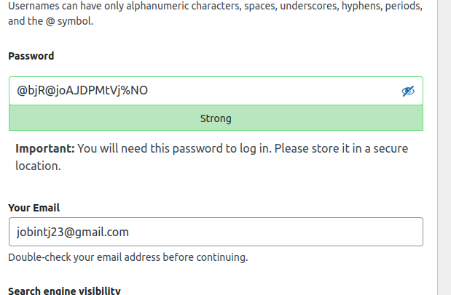

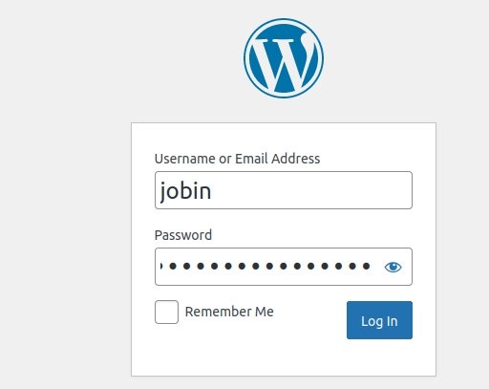



**NETWORKING & SYSTEM ADMINISTRATION LAB**

|  |
| --- |
| **Name: jobin t j**  **Roll No:7**  **Batch:MCA-B**  **Date:06-04-2022** |

**Experiment No: 6**

**Aim**

Build and install software from source code, familiarity with cmake utility expected.

**Procedure**

1. Sudo apt install cmake g++ make : **To install cmake , g++ and make using the apt command.**

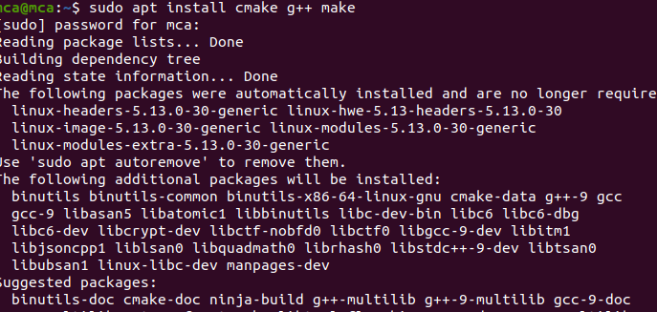

**2.mkdir myproject :** creating a different directory for our project using the [mkdir](https://www.linuxfordevices.com/tutorials/linux/the-mkdir-command-in-linux) and [cd](https://www.linuxfordevices.com/tutorials/linux/cd-command-in-linux) commands

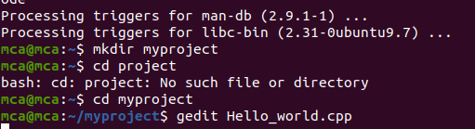

3.Now create a C++ source file named Hello_world.cpp and add the following

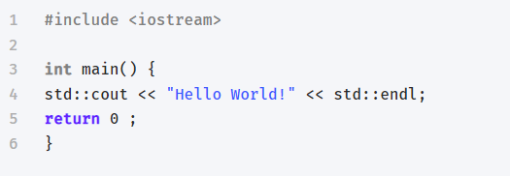

4.Create a CMakeLists.txt file(with this exact capitalization) which is required by CMake:

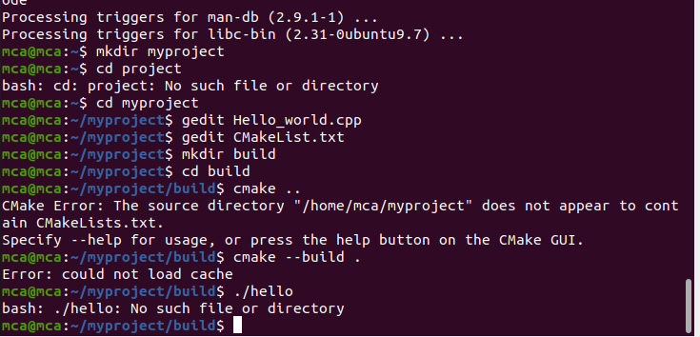

The CMakeLists.txt file for this project will only contain these three lines

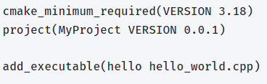

6.Build directory for executables :



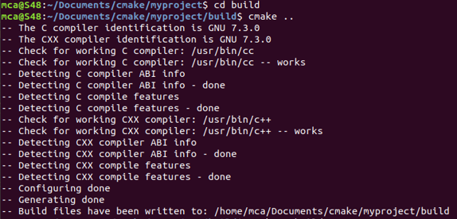

**7.cmake –build :** To generate the executable simply by typing:



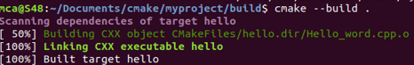

**8./hello :** Run the executable by typing:





**NETWORKING & SYSTEM ADMINISTRATION LAB**

|  |
| --- |
| **Name: jobin t j**  **Roll No:7**  **Batch:MCA-B**  **Date:06-04-2022** |

**Experiment No: 7**

**Aim**

Introduction to command line tools for networking IPv4 networking, network commands: ping route traceroute, nslookup, ip. Setting up static and dynamic IP addresses. Concept of Subnets, CIDR address schemes, Subnet masks, iptables, setting up a firewall for LAN, Application layer (L7) proxies.

**Procedure**

**1. ipconfig**

This commands in windows allows you to see a summarized information of your network such as ip address, subnet mask , server address etc.

**Syntax :-** $ ipconfig

**Output :-**

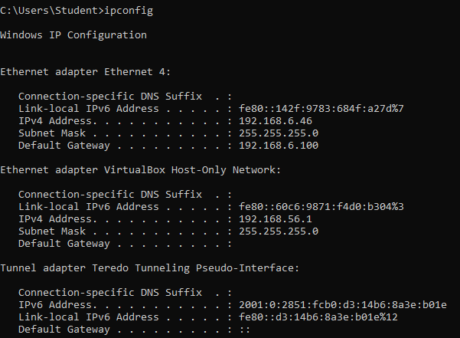

**2. ipconfig/all**

To see the the network information in detail. It is an extension of ipconfig command

**Syntax :-** $ ipconfig/all

**Output** :-

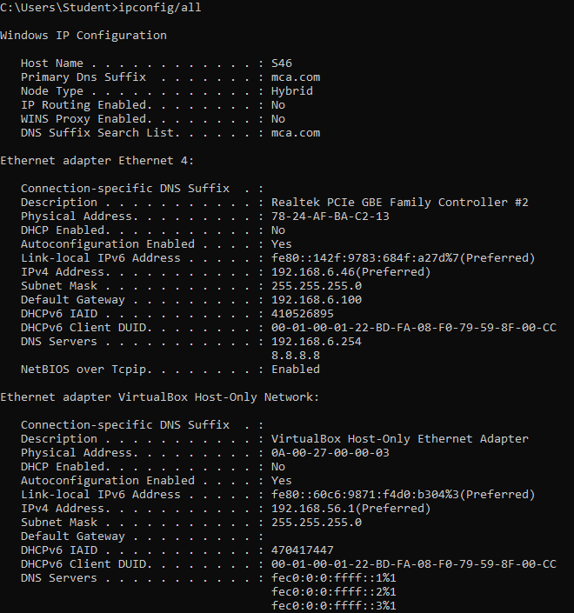

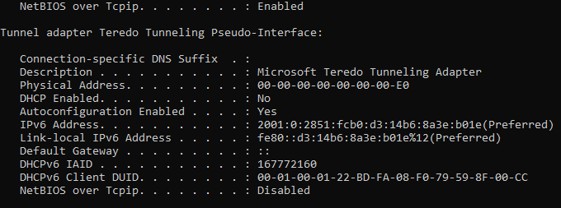

**3.** **nslookup**

To show the server to which the system is connected by default. If we want to find the ip address of a particular domain name, we can also use nslookup

**Syntax :-** $ nslookup

**Output :-**

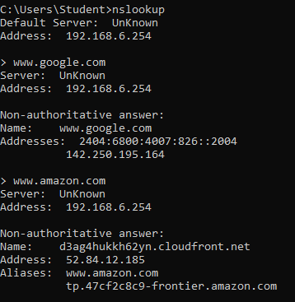

**4. ping**

The command used to check the availability of a host. The response shows the URL you are pinging, the ip address associated with the URL and the size of packets being sent on the first line . The next four lines shows the replies from each individual packets including the time(in milliseconds) for the response and the time to live(TLL) of the packet, that is the amount of time that must pass before the packet discarded.

**Syntax :-**  $ ping <IP_address>

**Output :-**

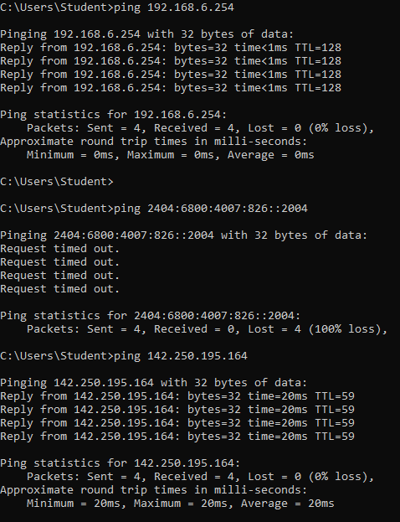

**5. tracert**

The command used to show the packets that are passed through the router to which our system is connected to.

**Syntax :-** $ tracert <ip_address_of_system>

**Output :-**

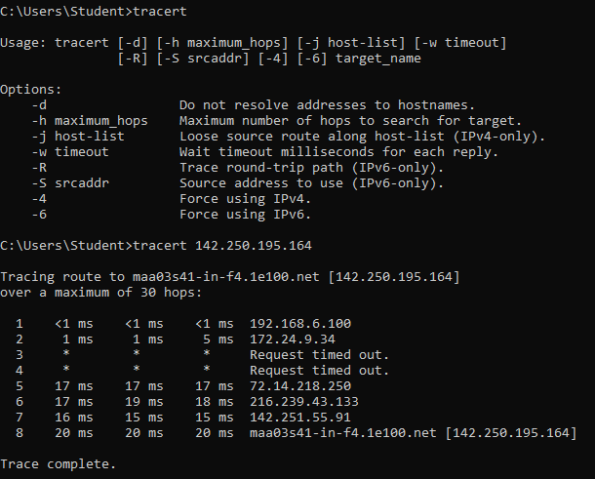

**6. route print**

The command used to display and updates network routing table

**Syntax :-** $ route print

**Output :-**

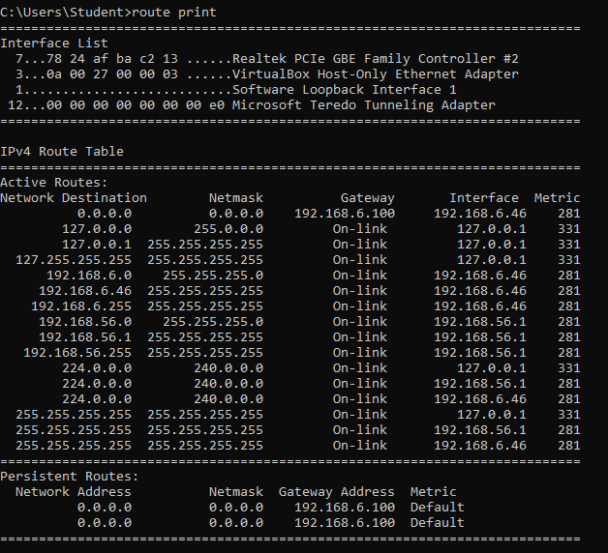

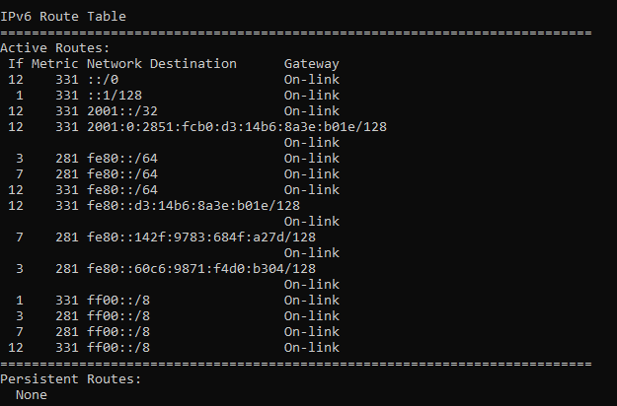

**7. netstat**

The network statistics or netstat command is a networking tool used for troubleshooting and configuration that can also serve a monitoring tool for the connections over the network.

**Syntax :-** netstat

**Output :-**

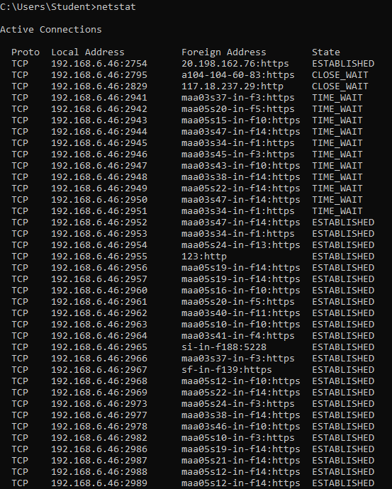

**NETWORKING & SYSTEM ADMINISTRATION LAB**

|  |
| --- |
| **Name: jobin t j**  **Roll No:7**  **Batch:MCA-B**  **Date:06-04-2022** |

**Experiment No: 8**

**Aim**

Analyzing network packet stream using tcpdump and wireshark. Perform basic network service tests using nc

**Procedure**

**1. update and install**

This command is used to install and update tcpdump.

Syntax :- $ sudo apt update && sudo apt install tcpdump

Output :-

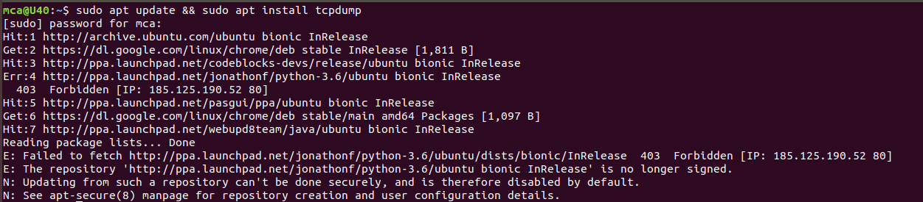

**2. sudo tcpdump**

This command is used to show all the interfaces connected to the inertnet packets.

Syntax :- $ sudo tcpdump

Output :-

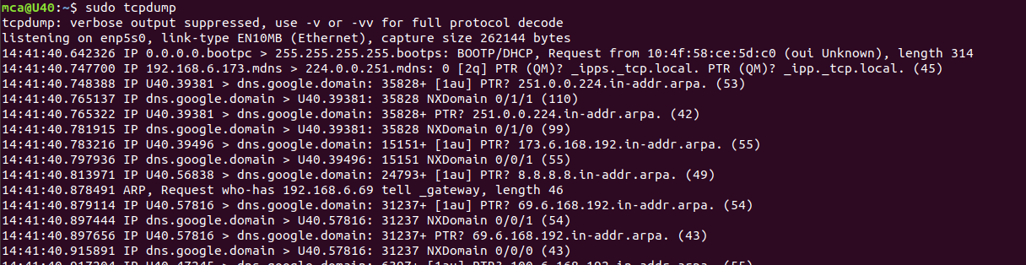

**3. -D**

This command is used to find specific interfaces.

Syntax :- $ sudo tcpdump -D

Output :-

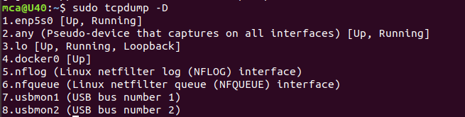

**4. -i**

This command is used to find the interface which is connected to our system.

Syntax :- $ sudo tcpdump -i enp5s0

Output :-

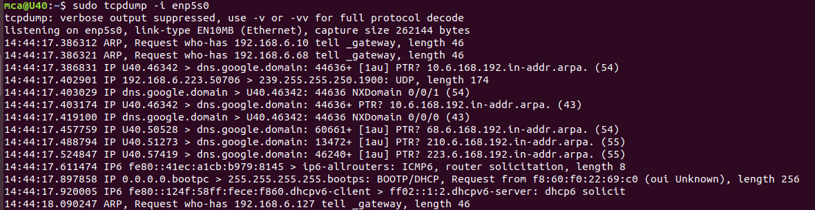

**5. -c 5 -i**

This command is used to access only 5 packets.

Syntax :- $ sudo tcpdump -c 5 -i enp5s0

Output:-

**6. -xx -i**

This command is used show all nformation in ASCII value.

Syntax :- $ sudo tcpdump -xx -i enp5s0

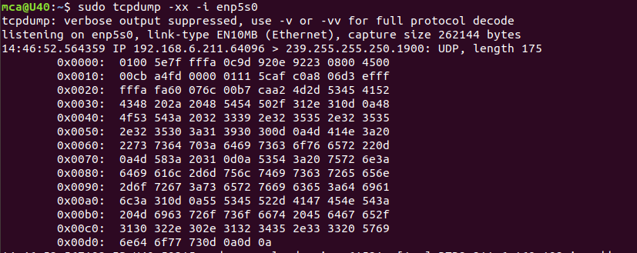Output :-

**7. sudo tcpdump -i enp5s0 -c 5 port 80**

This command is used to show a specified number of packets in that particular port number.

Syntax :- $ sudo tcpdump -i enp5s0 -c 5 port 80

Output :-

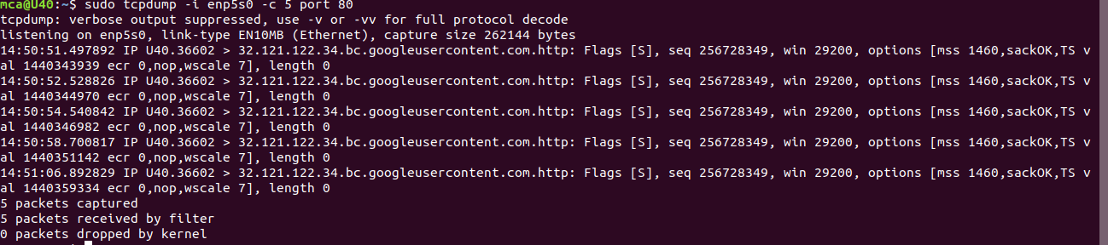

**8. sudo tcpdump -i enp5s0 icmp**

Syntax :- $ sudo tcpdump -i enp5s0 icmp

Output :-

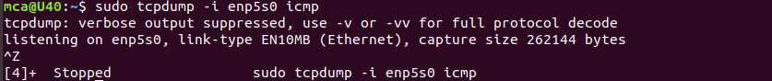

**9. sudo tcpdump -i enp5s0 -c 10 -w icmp.filename**

This command is used to capturing packets and stored in a pcap file.

Syntax :- $ sudo tcpdump -i enp5s0 -c 10 -w icmp.filename

Output :-

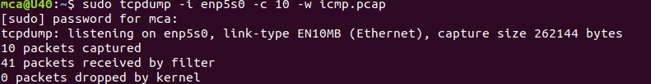

**10. sudo tcpdump -r icmp.filename**

This command use to read that particular file using -r flag.

Syntax :- $ sudo tcpdump -r icmp.filename

Output :-

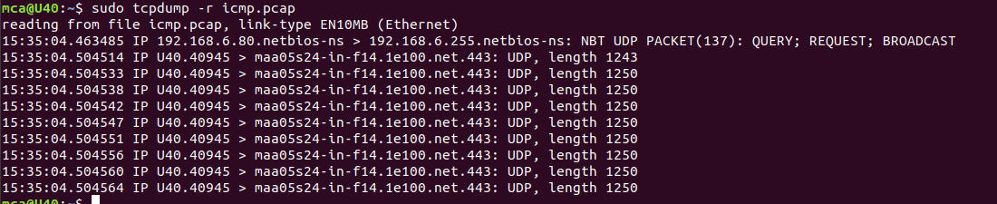

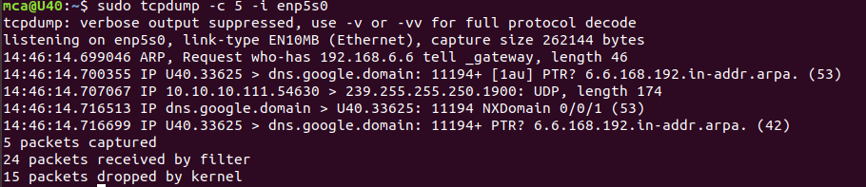

**NETWORKING & SYSTEM ADMINISTRATION LAB**

|  |
| --- |
| **Name: jobin t j**  **Roll No:7**  **Batch:MCA-B**  **Date:06-04-2022** |

**Experiment No: 9**

**Aim**

Introduction to Hypervisors and VMs: KVM installation and commands

**Procedure**

**Step 1:** Update the repositories

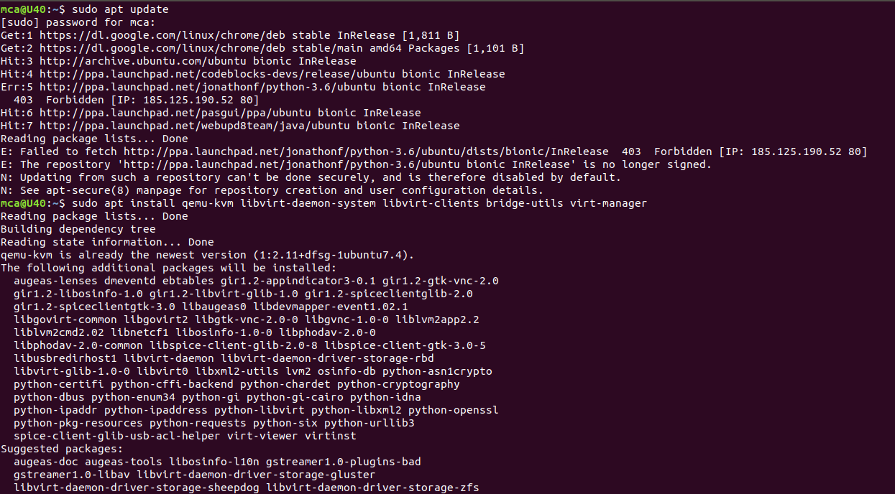

**Step 2:** Install essential KVM packages

 Install virt-manager, a tool for creating and managing VMs



Step 3: Start virt-manager with

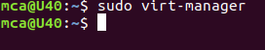

Step 4:In the first window, click the computer icon in the upper-left corner,

In the dialogue box that opens, select the option to install the VM using an ISO image. Then click **Forward**.

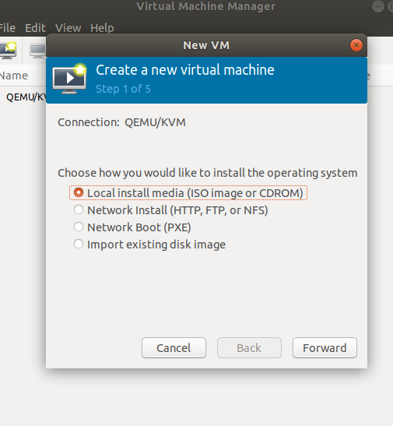

Step 5: Choose ISO,click Forward

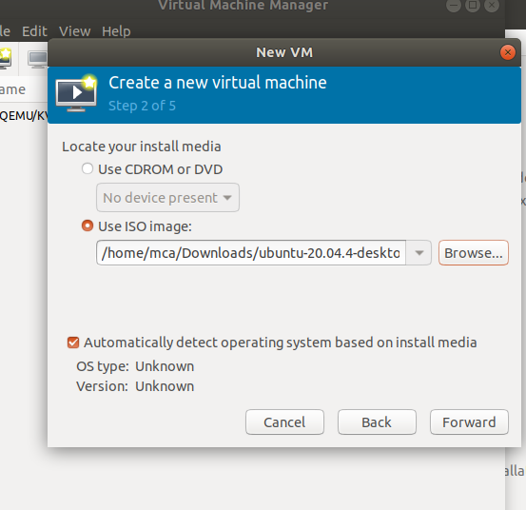

Step 6: Enter the amount of RAM and the number of CPUs you wish to allocate to the VM and proceed to the next step.

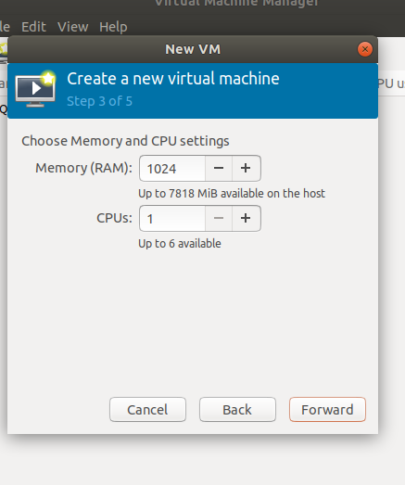

Step 7:  Allocate hard disk space to the VM. Click **Forward** to go to the last step.

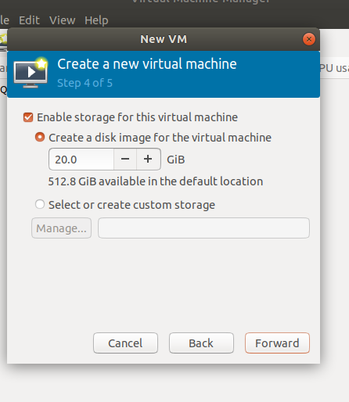

Step 8:  Specify the name for your VM and click **Finish** to complete the setup.

Step 9: Select language

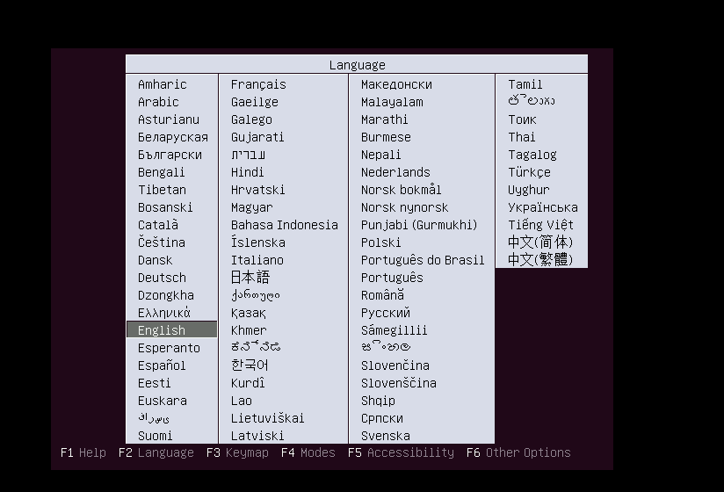

Step 10: The VM starts automatically, prompting you to start installing the OS that’s on the ISO file.

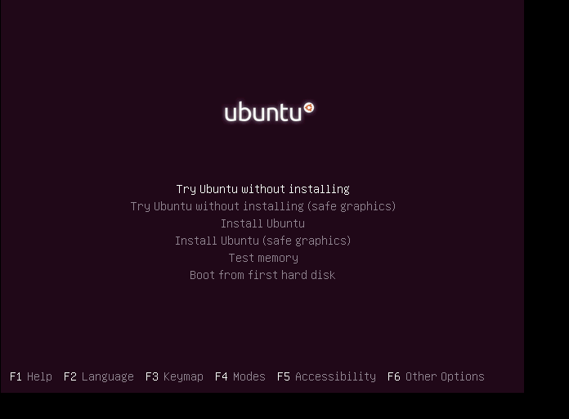

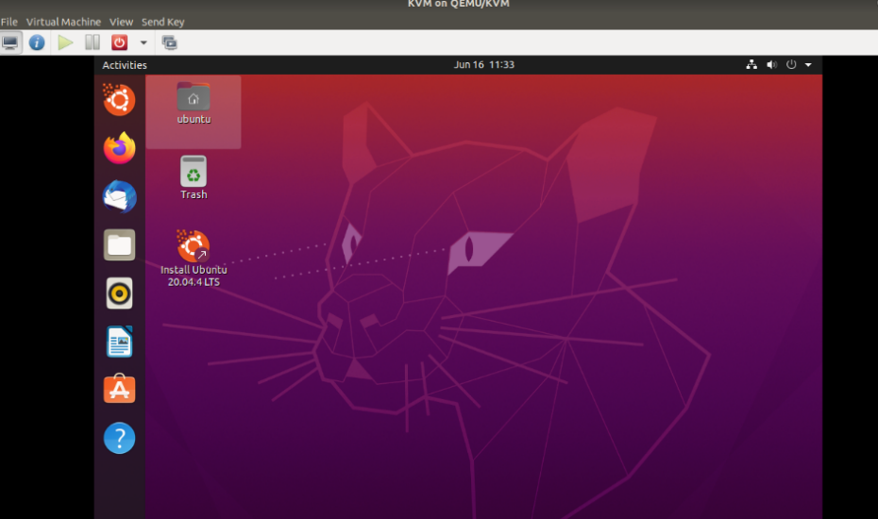

Step 11: Check the state of KVM

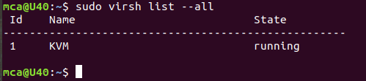

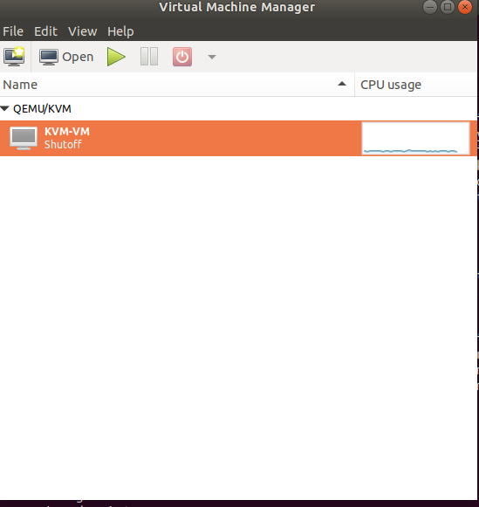

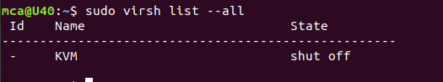

**NETWORKING & SYSTEM ADMINISTRATION LAB**

|  |
| --- |
| **Name: jobin t j**  **Roll No:7**  **Batch:MCA-B**  **Date:06-04-2022** |

**Experiment No: 9**

**Aim**

Introduction to Containers: Docker installation and deployment.

**Procedure**

**Step 1:**  Open the terminal on Ubuntu.

**Step 2:** Remove any docker files that are running in the system, using the following

**Command:**

$ sudo apt-get remove docker docker-engine docker.io

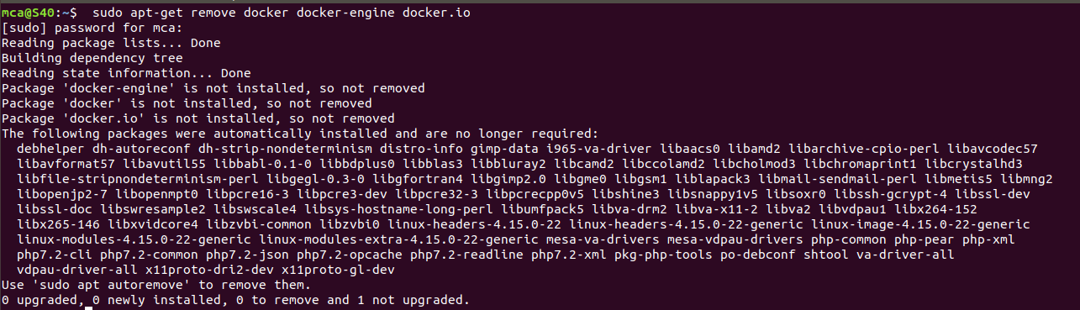

**Step 3:** Check if the system is up-to-date using the following command:

**Command:**

$ sudo apt-get update

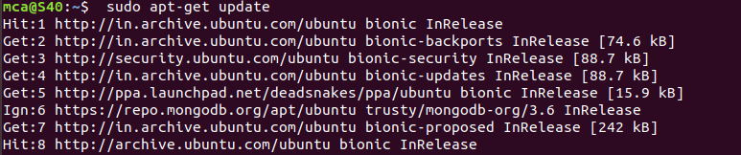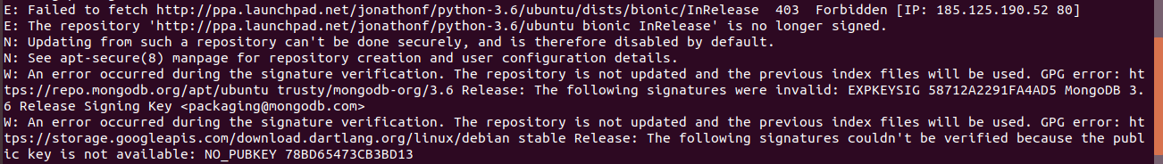

Step 4: Install Docker using the following command:

**Command:**

$ sudo apt install docker.io

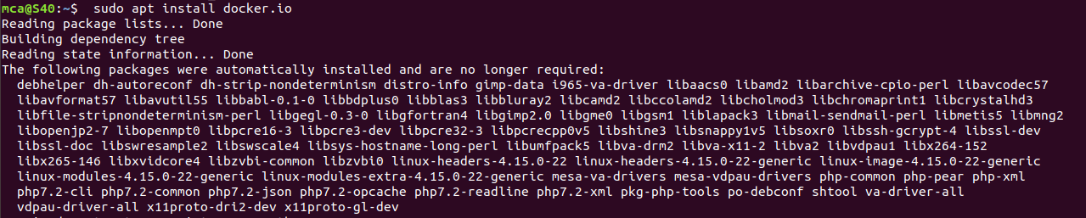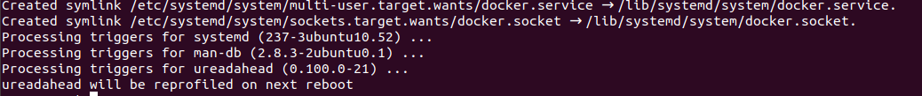

Step 5: Install all the dependency packages using the following command:

**Command:**

$ sudo snap install docker



Step 6: Before testing Docker, check the version installed using the following command:

**Command:**

$ docker –version



Step 7: Pull an image from the Docker hub using the following command:

**Command:**

$ sudo docker run hello-world

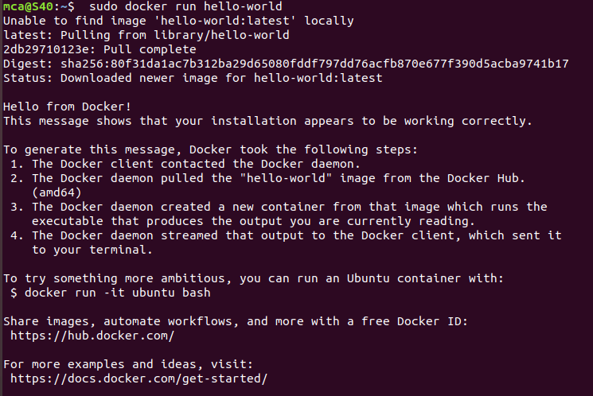

Step 8: Check if the docker image has been pulled and is present in your system using

the following command:

**Command:**

$ sudo docker images



Step 9: To display all the containers pulled, use the following command:

**Command:**

$ sudo docker ps -a



Step 10: To check for containers in a running state, use the following command:

**Command:**

$ sudo docker ps



**Step 1:** Pull Docker Apache Container

**Command:**

**$ sudo docker run -dit --name tecmint-web -p 8080:80 -v /home/user/website/:/usr/local/apache2/htdocs/ httpd:2.4**

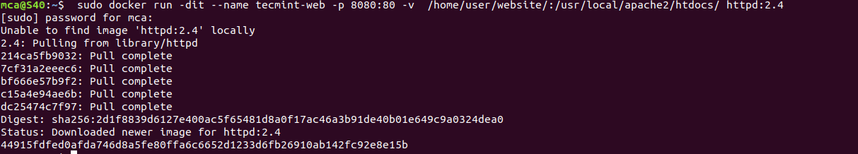

At this point, our Apache container should be up and running.

**Step 2:** Check Apache Docker Container.

**Command:**

**$ sudo docker ps**



Now let’s create a simple web page named docker.html inside the /home/user/website directory.

**Step 3:**

**$ sudo gedit /home/user/website/docker.html**

Add the following sample HTML content to the file.

<!DOCTYPE html>

<html lang="en">

<head>

<meta charset="UTF-8">

<title>Learn Docker at Tecmint.com</title>

</head>

<body>

<h1>Learn Docker With Us</h1>

</body>

</html>

Next, point your browser to Server-IP:8080/docker.html (where Server-IP is your host’s public IP address). You should be presented with the page we created previously.

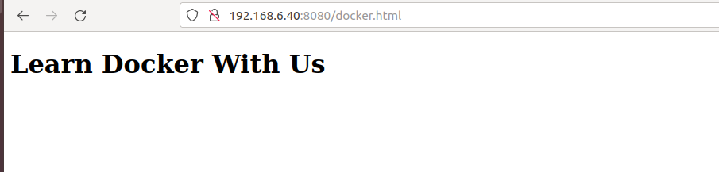

**Step 5:** If you wish, you can now stop the container.

**$ sudo docker stop tecmint-web**

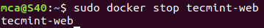

**Step 6:**  Remove it

**Command:**

**$ sudo docker rm tecmint-web**



**Step 7 :** To finish cleaning up, you may want to delete the image that was used in th container (omit this step if you’re planning on creating other Apache 2.4 containers soon).

**Command:**

**$ sudo docker image remove httpd:2.4**